# Web Application Development Coursework

# Testing Report

# Peter J. McMillan S1937053

Contents

Introduction 3

Section 1: Testing of features accessible to non-logged in users 4

Section 2: Login and verification 12

Section 3: Testing of features only accessible to logged in users 17

Testing Summary 31

## Introduction

This report describes the process of testing the restaurant web application to ensure it works as intended and meets the specification.

The testing process will be divided into three sections each focusing on a specific aspect of the application’s functionality. The sections are:

1. Features accessible to non-logged in users
2. Login and verification
3. Features only accessible to logged in users

A table will be presented for each section of testing listing the action carried out, the expected results and actual results. This will be accompanied by screenshots giving evidence of the test findings.

## Section 1: Testing of features accessible to non-logged in users

|  |  |  |  |  |
| --- | --- | --- | --- | --- |
| Test ID | Action | Expected Outcome | Actual Outcome | Evidence |
| 1.1 | Navigate to localhost:3000 in web browser. | The “about” page will be displayed. | The “about” page is displayed. | See screenshot 1 |
| 1.2 | Navigate to localhost:3000 then click “Today’s Menus” button | The “menus” page will be displayed | The “menus” page is displayed | See Screenshot 2 |
| 1.3 | Navigate to localhost:3000/menu | The “menus” page will be displayed | The “menus” page is displayed | See Screenshot 3 |
| 1.4 | Navigate to localhost:3000 then click “Contact Us” button | The “Contact” page will be displayed | The “contact” page is displayed | See screenshot 4 |
| 1.5 | Navigate to localhost:3000/contact | The “Contact” page will be displayed | The “contact” page is displayed | See screenshot 5 |
| 1.6 | Navigate to contact page and leave a message (all inputs provided) | A message saying the message was received will be displayed before being redirected back to the landing page. The console log will show the message details. | A message saying the message was received was displayed before being redirected back to the landing page. The console log shows the message details. | See screenshots 6-8 |
| 1.7 | Navigate to contact page and leave a message omitting the “name” input | A message requesting all inputs will be displayed. The comment will not be added to the database. | A message requesting all inputs was displayed. The comment was not added to the database. | See screenshot 9 |
| 1.8 | Navigate to contact page and leave a message omitting the “email address” input | A message requesting all inputs will be displayed. The comment will not be added to the database. | A message requesting all inputs was displayed. The comment was not added to the database. | See screenshot 10 |
| 1.9 | Navigate to contact page and leave a message omitting the “Comment” input | A message requesting all inputs will be displayed. The comment will not be added to the database. | A message requesting all inputs was displayed. The comment was not added to the database. | See screenshot 11 |
| 1.10 | Navigate to contact page and leave a message which contains html tags | The message will be inserted into the database but the HTML tags will not be rendered when a logged in user attempts to view the comments | The message was inserted into the database but the HTML tags were not rendered when a logged in user view the comments | See screenshots 12 and 13 |

Table 1: Testing of features accessible to non-logged in users.

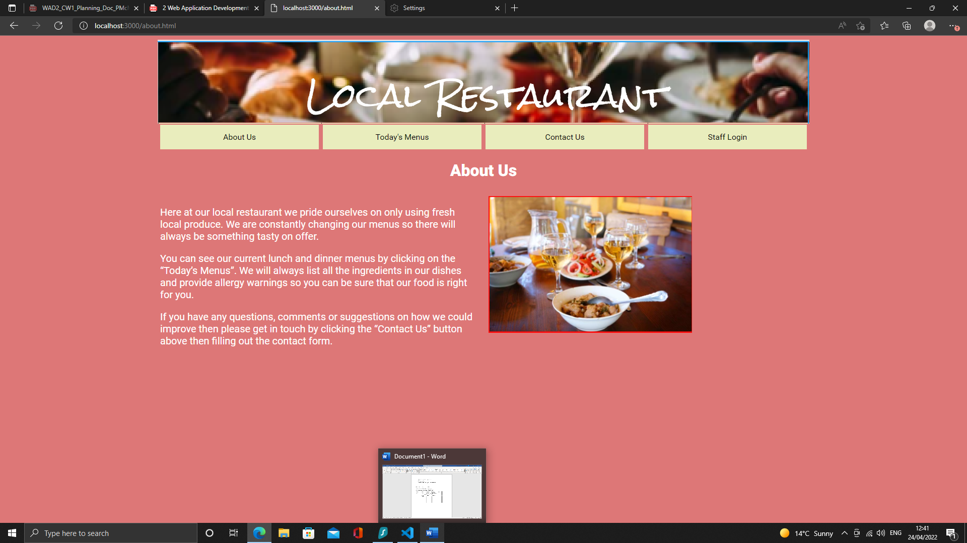

Screenshot 1

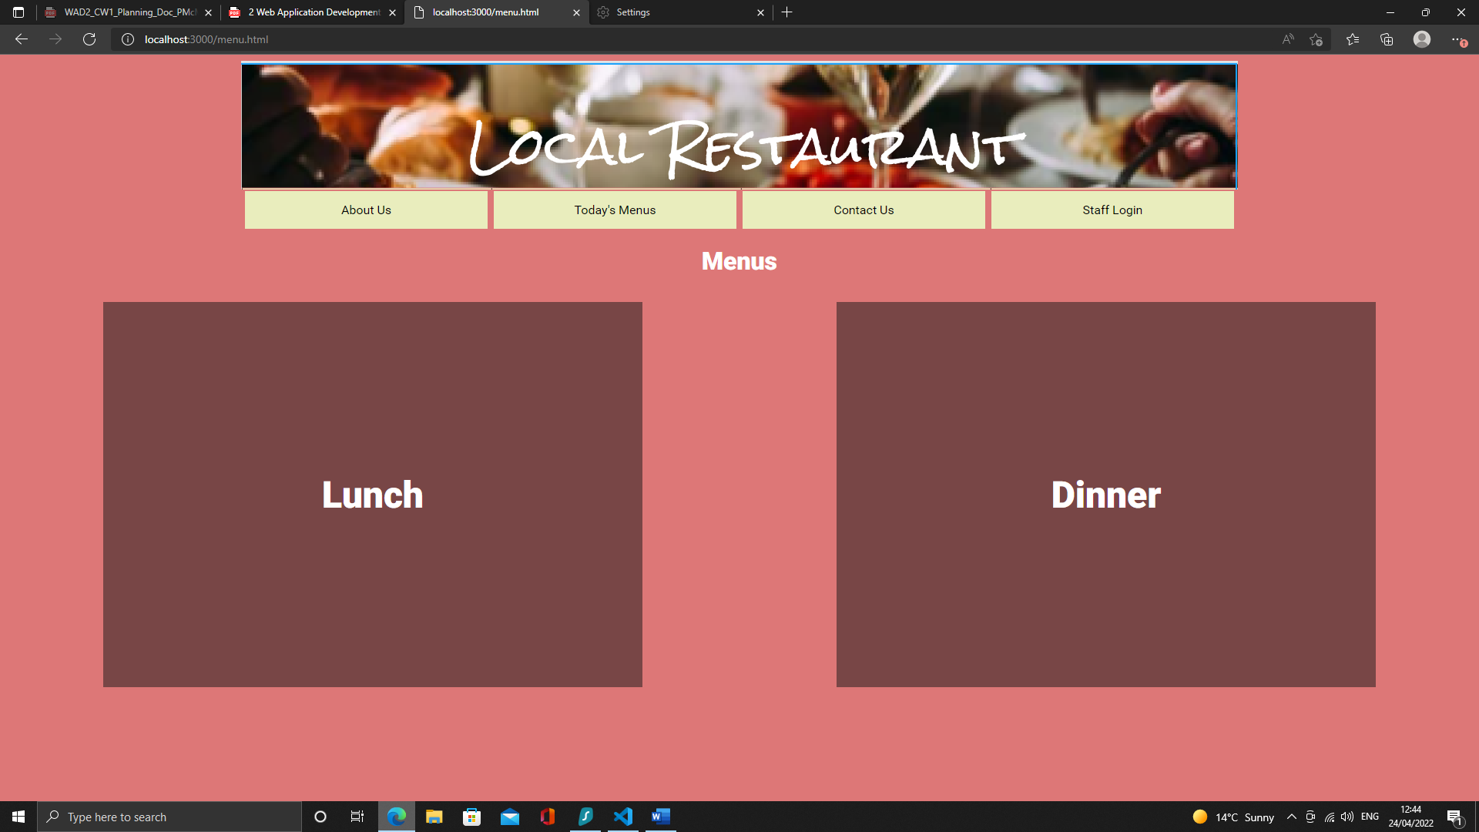

Screenshot 2



Screenshot 3

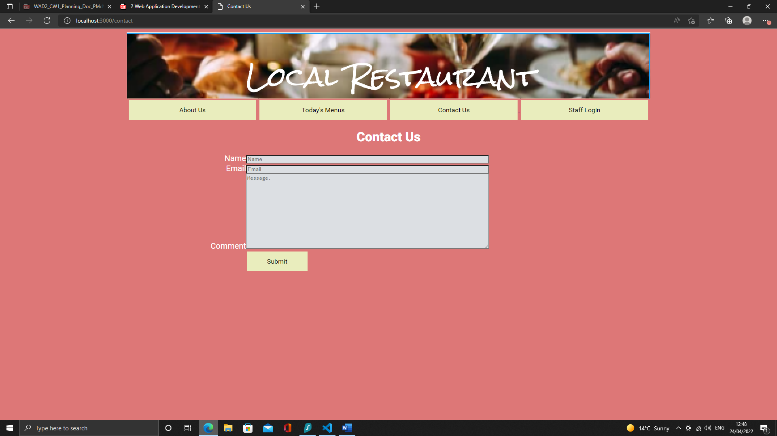

Screenshot 4

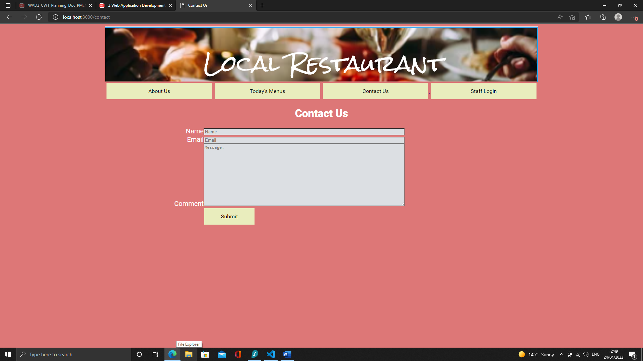

Screenshot 5

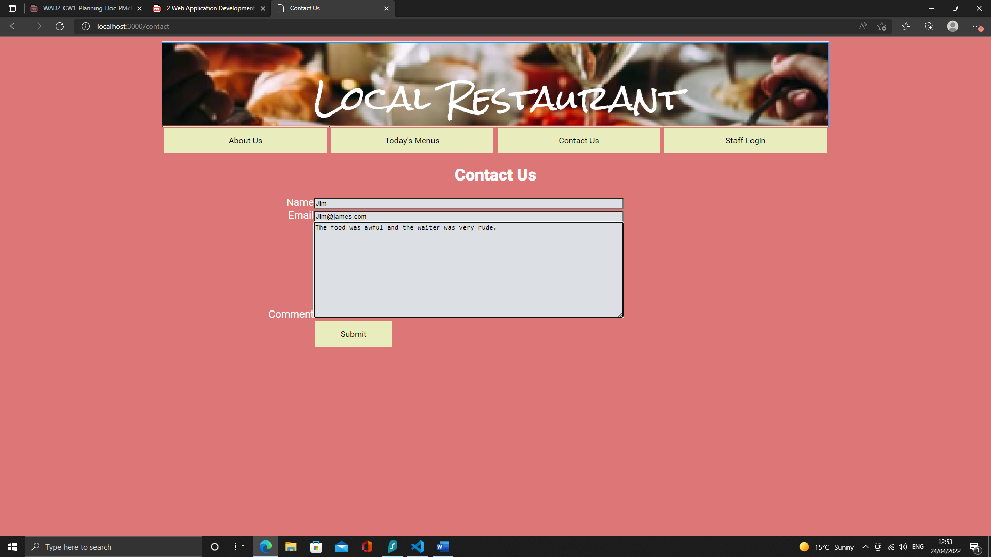

Screenshot 6

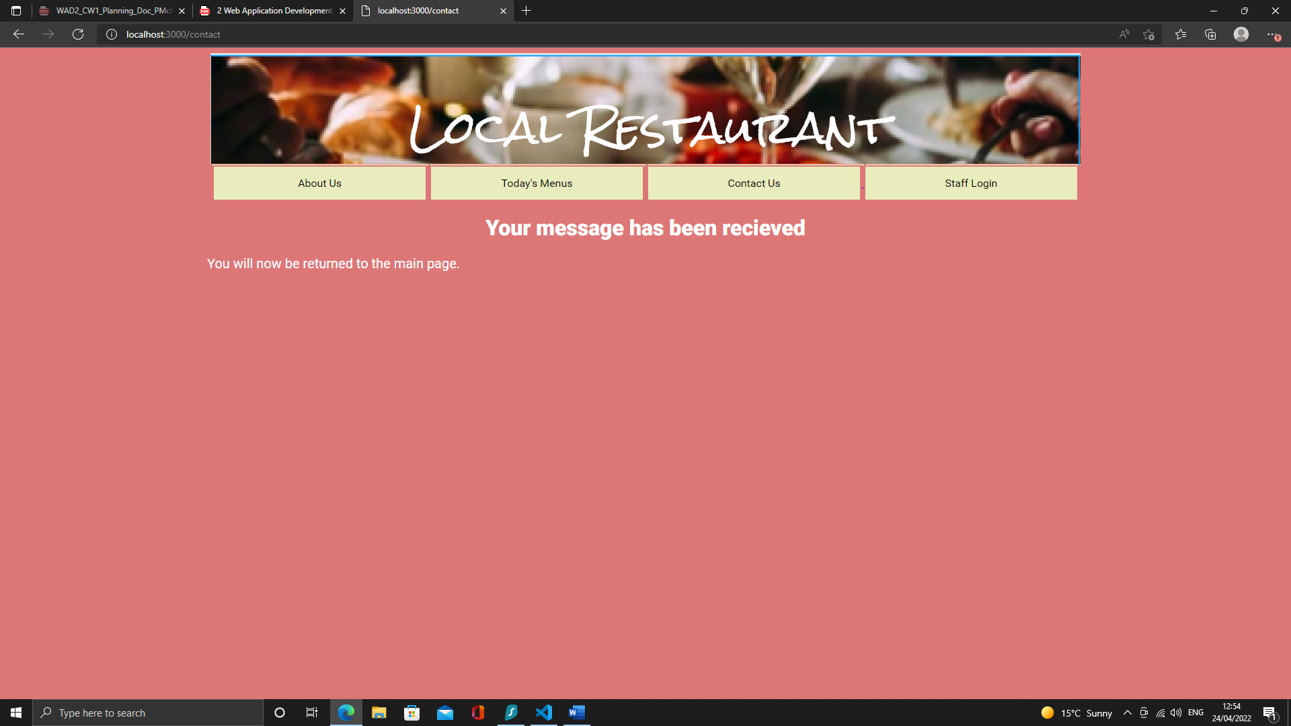

Screenshot 7

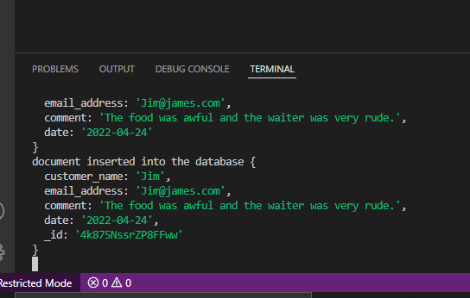

Screenshot 8

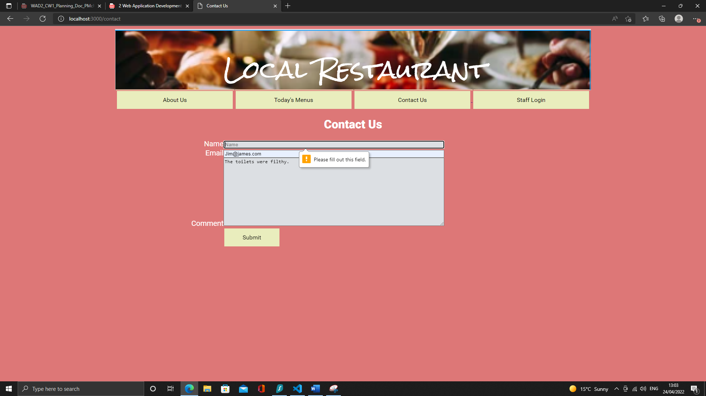

Screenshot 8

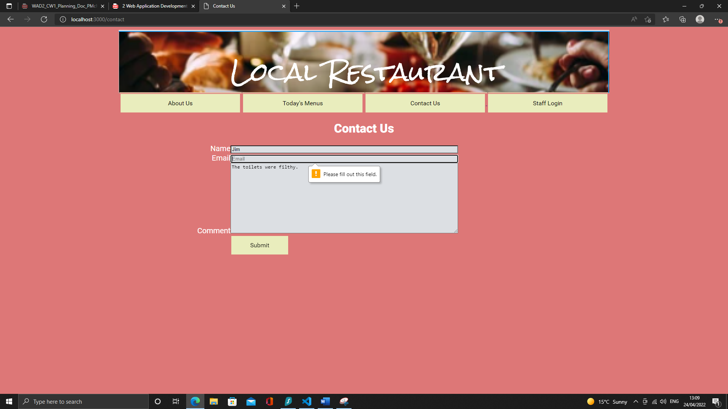

Screenshot 10

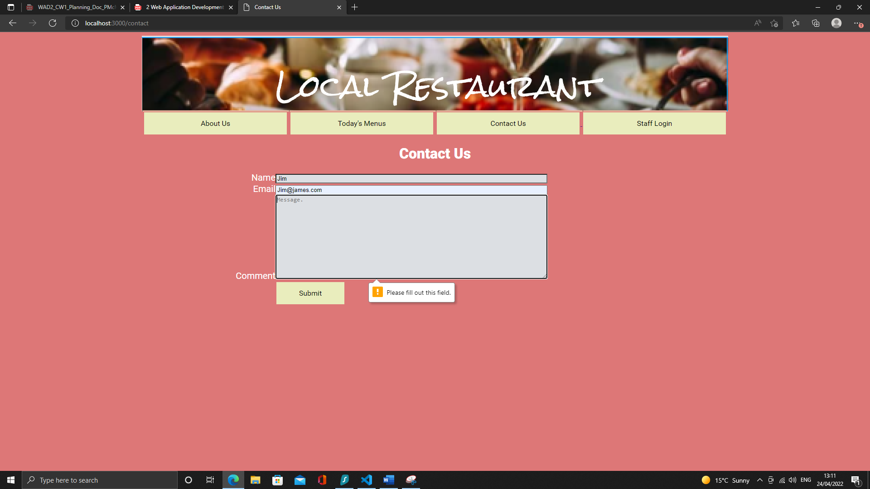

Screenshot 11

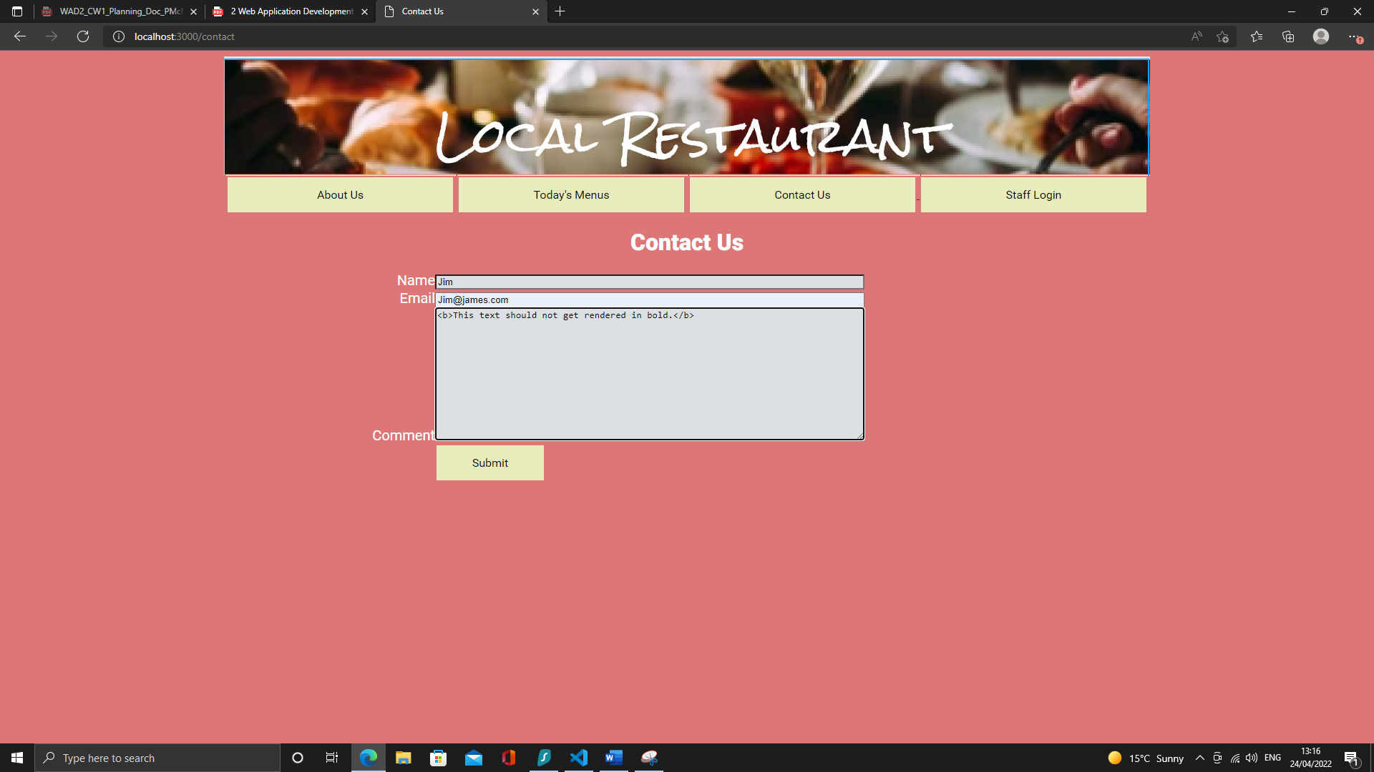

Screenshot 12

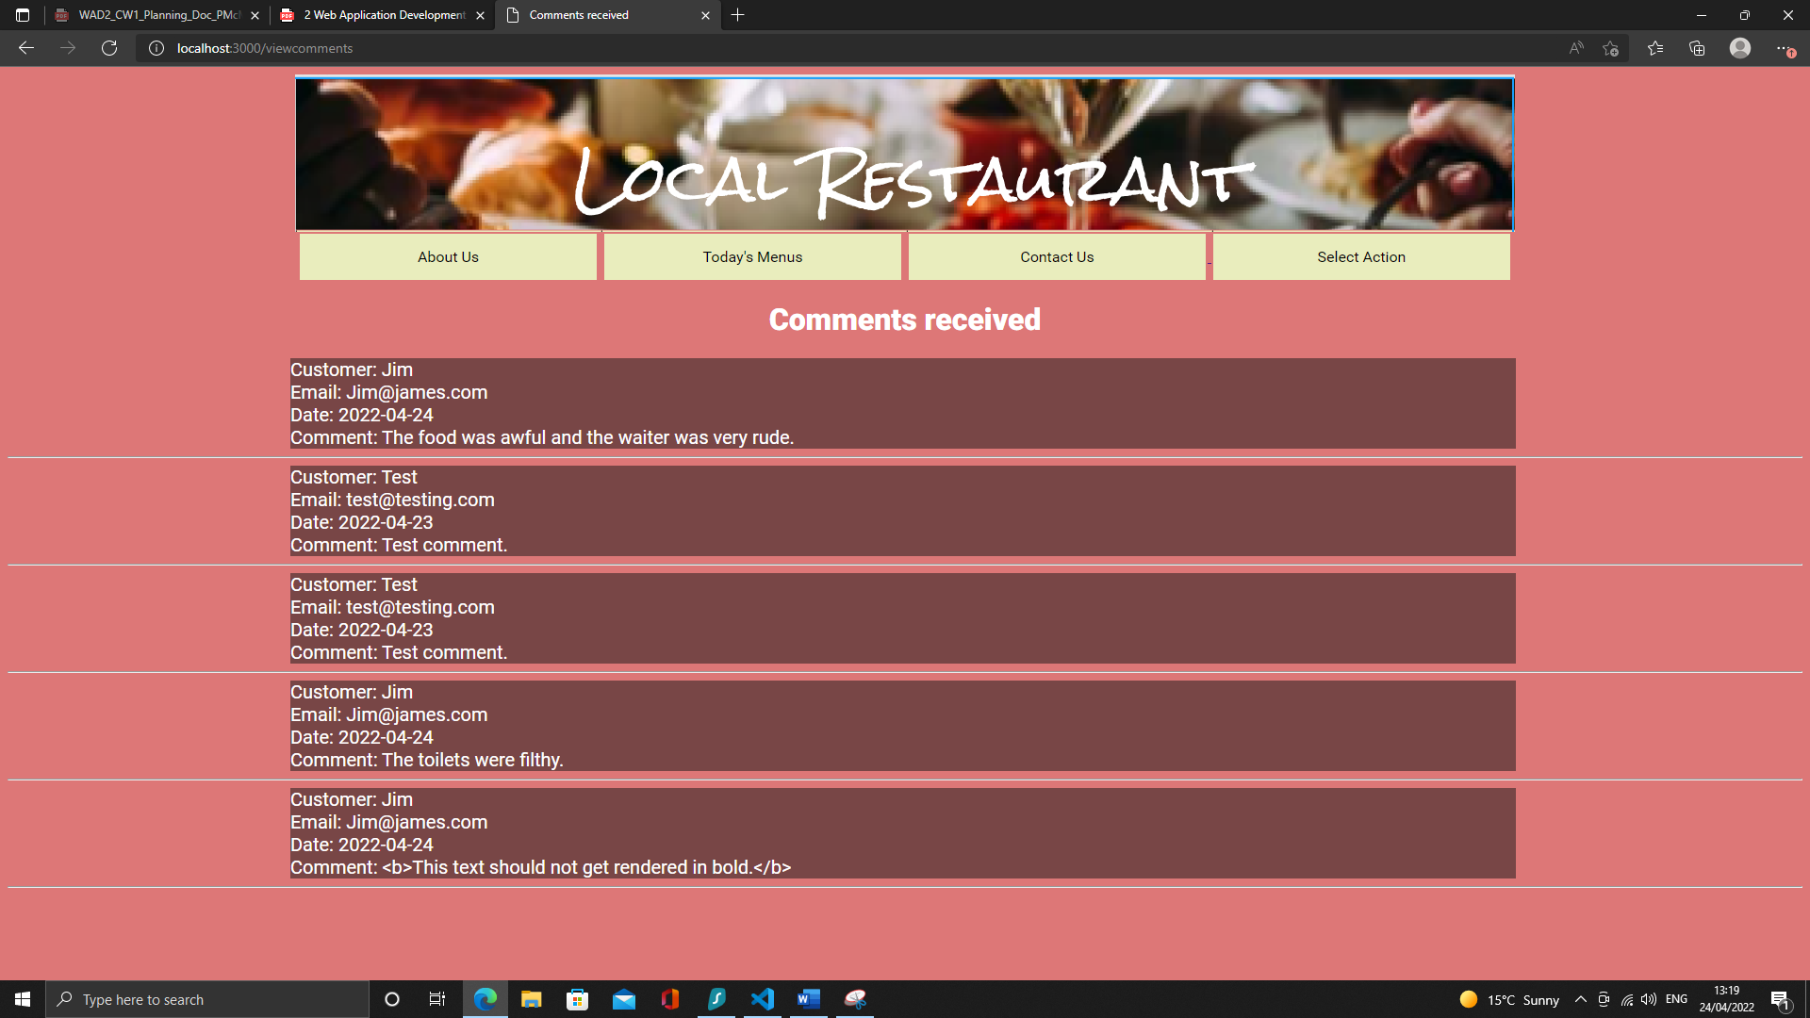

Screenshot 13

## Section 2: Login and verification

|  |  |  |  |  |
| --- | --- | --- | --- | --- |
| Test ID | Action | Expected Outcome | Actual Outcome | Evidence |
| 2.1 | Navigate to localhost:3000 then click “Staff Login” button | The staff login screen will be displayed | The staff login screen was displayed | See screenshot 14 |
| 2.1 | Navigate to localhost:3000/login | The staff login screen will be displayed | The staff login screen was displayed | See screenshot 15 |
| 2.2 | Enter username: admin and password: Rest4ur4ntus3r! (valid credentials) and click confirm | The user will be logged in and taken to the “Action Select” page | The user was logged in and taken to the “Action Select” page | See screenshot 16 |
| 2.3 | Enter a valid username but an invalid password | The user will not be logged in | The user was not logged in | See screenshot 17 |
| 2.4 | Enter an invalid username and password | The user will not be logged in | The user was not logged in | See screenshot 18 |
| 2.5 | Navigate to localhost:3000/loggedin without first entering a username and password | A message saying the page is not accessible will be displayed | A message saying the page is not accessible was displayed | See screenshot 19 |
| 2.6 | Log in. Wait until session expires then click the “view comments” page | A message saying the page is not accessible will be displayed | A message saying the page is not accessible was displayed | See screenshot 20 |
| 2.7 | Click “log out button” on logged in landing page | The user will be redirected to the “about” page | Redirected to the “about” page | See screenshot 21 |

Table 2: Testing of logging in and verification

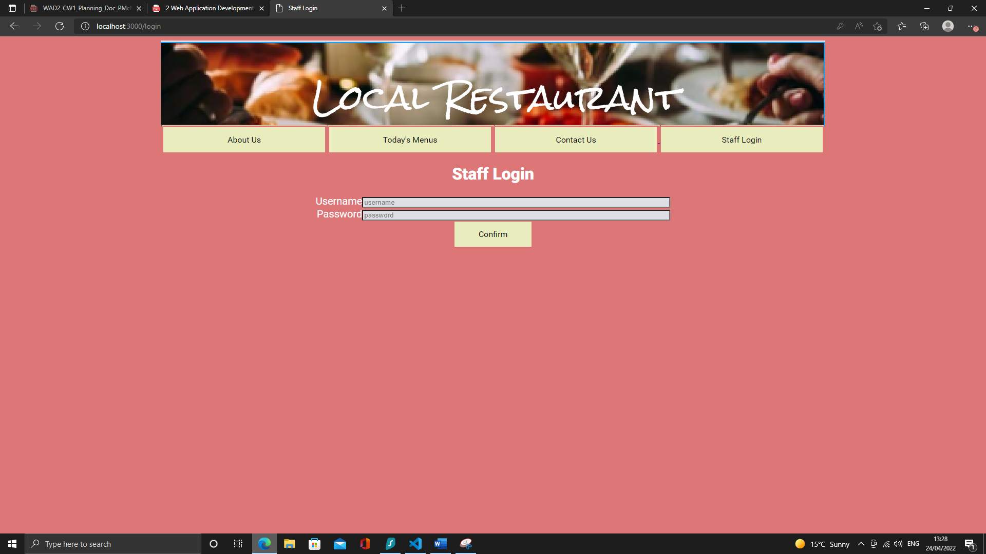

Screenshot 14

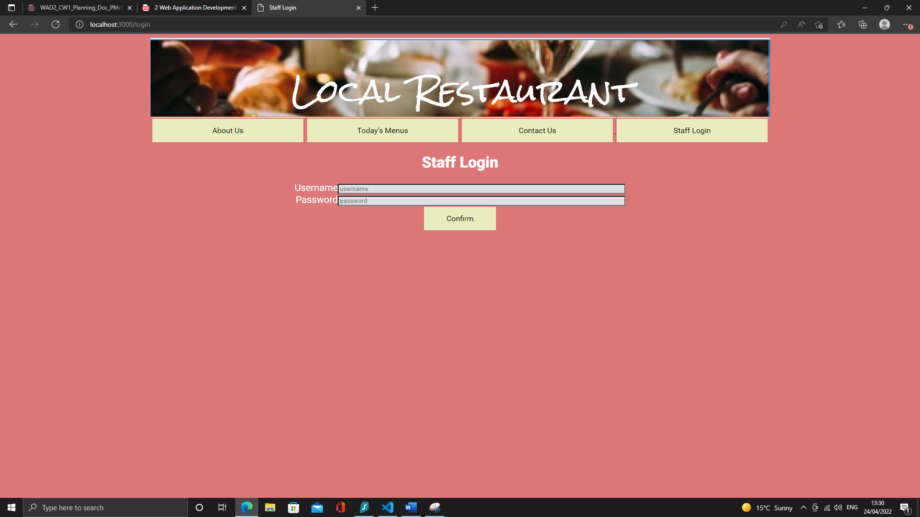

Screenshot 15

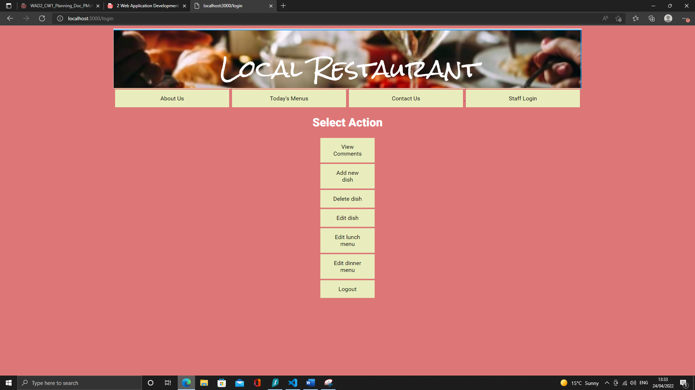

Screenshot 16

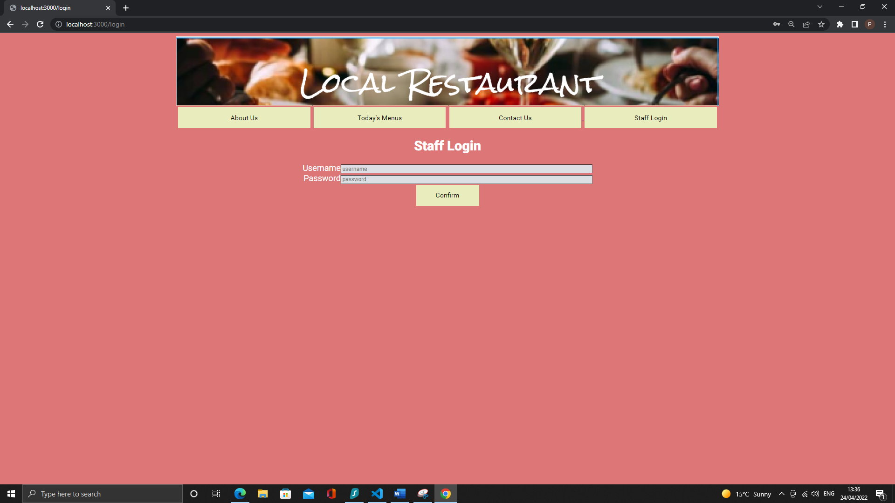

Screenshot 17



Screenshot 18

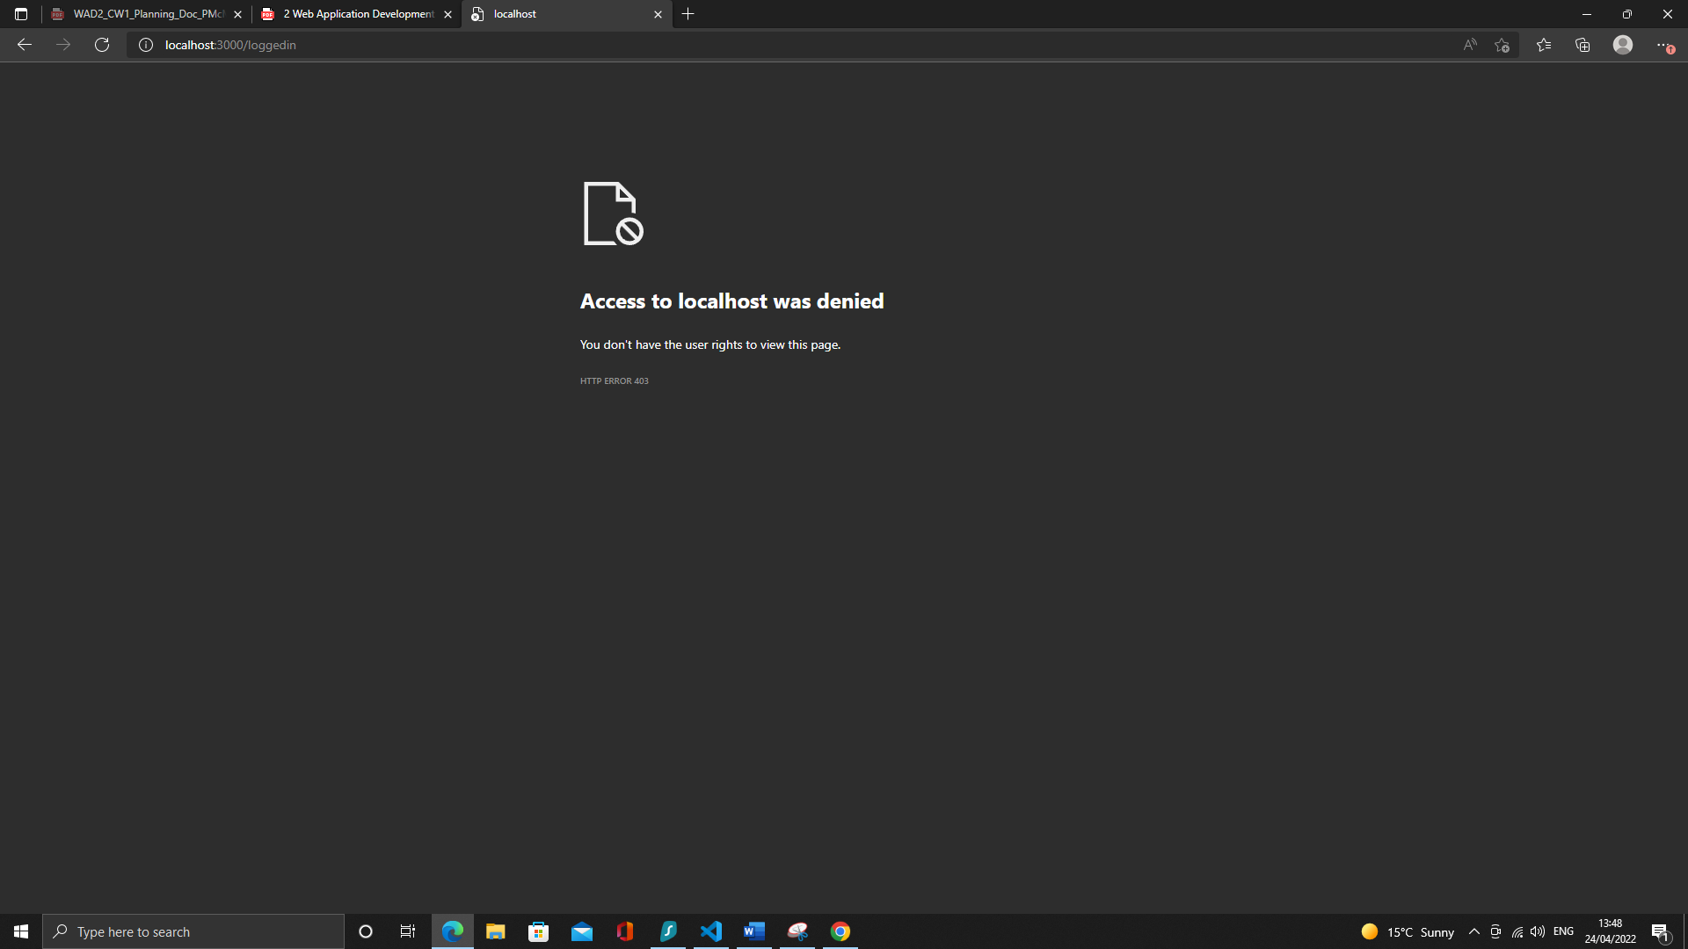

Screenshot 19

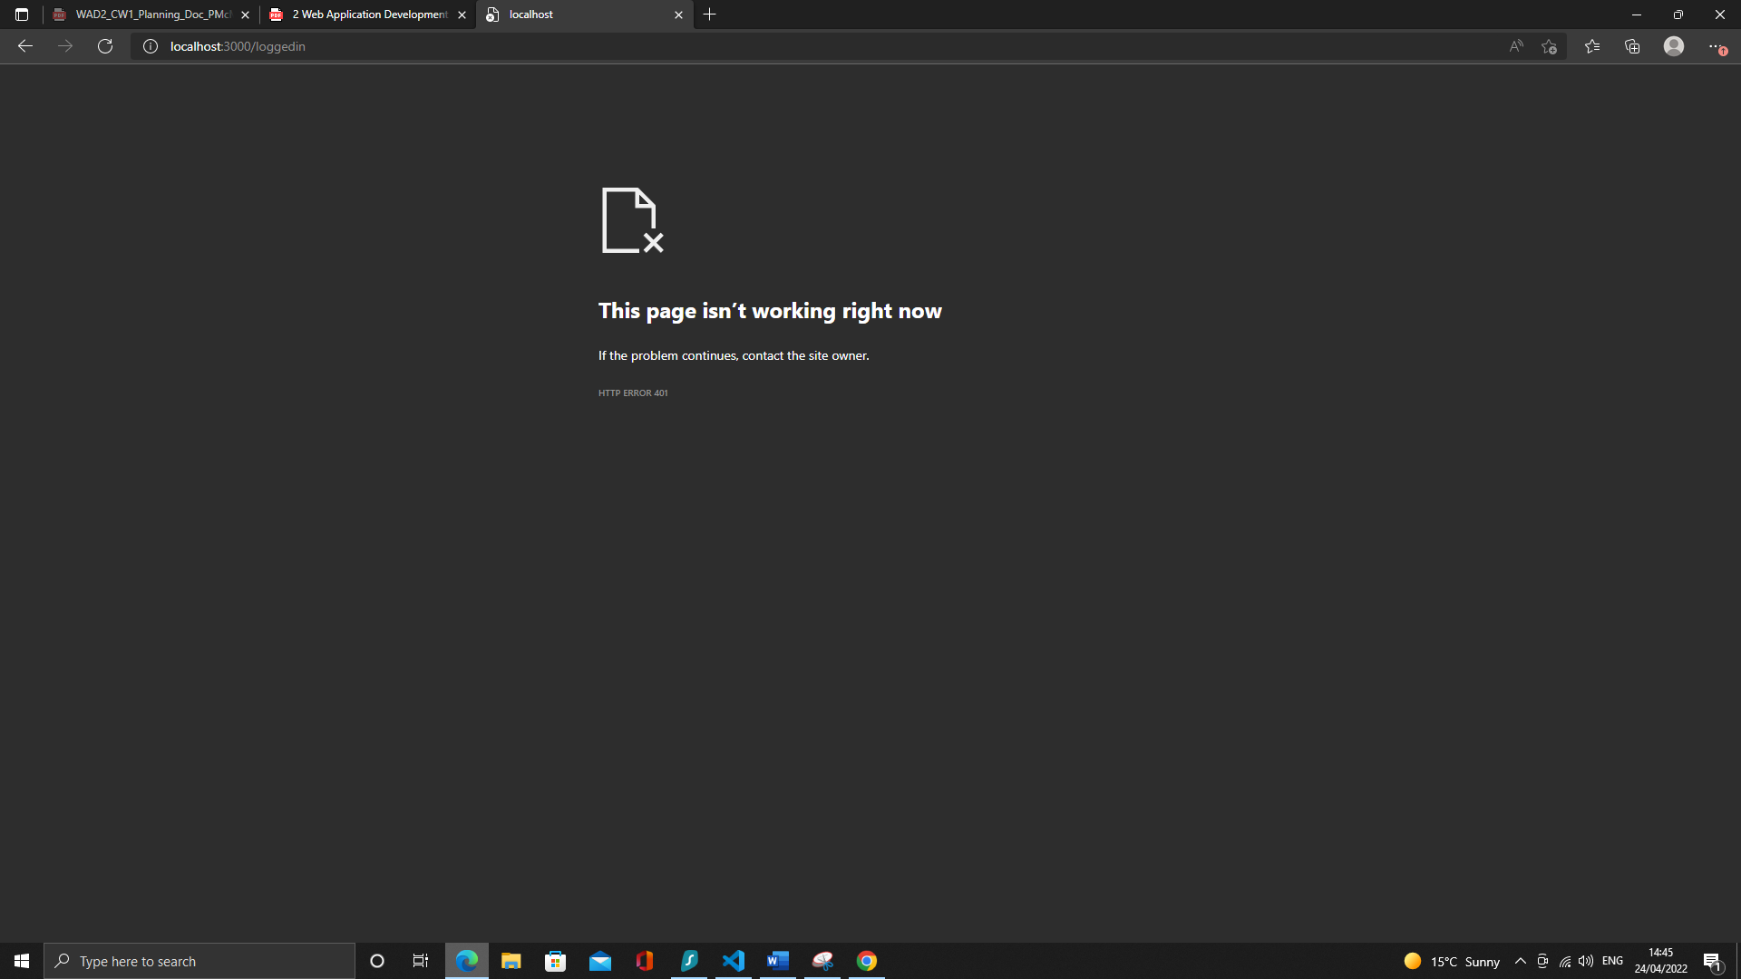

Screenshot 20

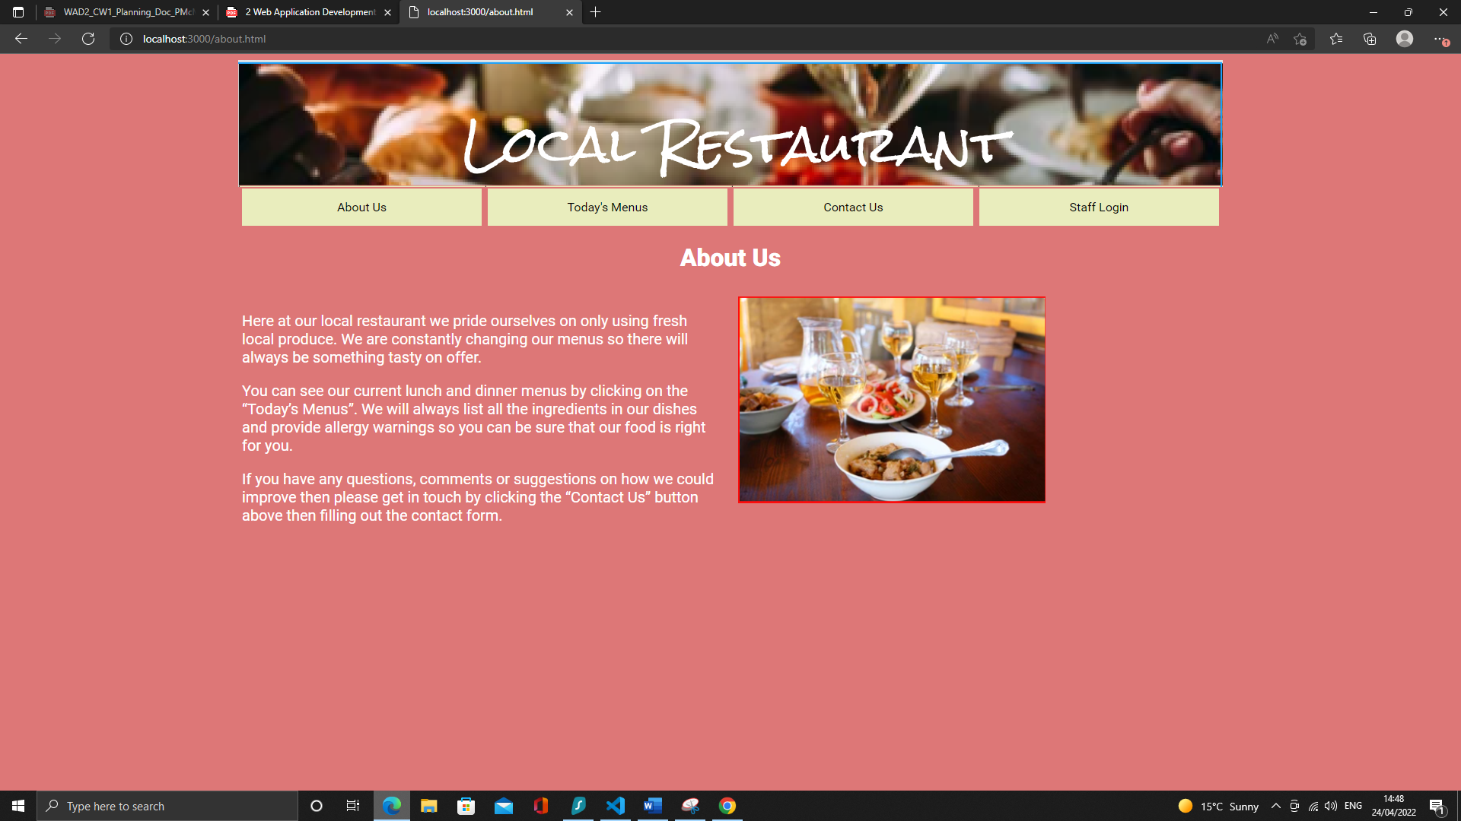

Screenshot 21

## Section 3: Testing of features only accessible to logged in users

|  |  |  |  |  |
| --- | --- | --- | --- | --- |
| Test ID | Action | Expected Outcome | Actual Outcome | Evidence |
| 3.1 | From logged in landing page click “View Comments” button | A list of previously entered comments will be displayed. | A list of previously entered comments was displayed. | See screenshot 21 |
| 3.2 | From logged in landing page click “Add new dish” button | Form to enter details of a new dish will be displayed | Form to enter details of a new dish was displayed | See screenshot 22 |
| 3.3 | Add new dish | Message saying dish was added will be displayed before user is redirected to logged in landing page. | Message saying dish was added was displayed before user is redirected to logged in landing page | See screenshot 23 |
| 3.4 | Add new dish (omit dish name) | Message requesting input is provided will be displayed | Message requesting input be provided was displayed. | See screenshot 24 |
| 3.5 | Add new dish with html tags in description | Dish will be added to the database but html will not be rendered on the display menu pages. | Dish was added to the database but html was not be rendered on the display menu pages. | See screenshot 25 |
| 3.6 | From logged in landing page click “Delete dish” button | Screen requesting dish to be deleted will be displayed | Screen requesting dish to be deleted was displayed | See screenshot 26 |
| 3.7 | Delete existing dish | Message saying dish was deleted will be displayed before user is redirected to the logged in landing page. Dish will no longer appear on menus | Message saying dish was deleted was displayed before user was redirected to the logged in landing page. Dish no longer appears on menus | See screenshot 27 |
| 3.8 | Attempt to delete non-existent dish | Error message saying dish was not found will be displayed. | Message saying dish was deleted was displayed before user was redirected to the logged in landing page. No dish was actually deleted however. | See screenshot 28 |
| 3.9 | From logged in landing page click “Edit dish” button | Screen requesting dish to edit will be displayed | Screen requesting dish to edit was displayed | See screenshot 29 |
| 3.10 | Change details of existing dish | Message saying dish was updated will be displayed before the user is redirected to the logged in landing page. Dish details will be updated on the menu page. | Message saying dish was updated was displayed before the user was redirected to the logged in landing page. Dish details were updated on the menu page. | See screenshot 30 |
| 3.11 | Attempt to change details of non-existent dish | Message saying dish was not found will be displayed. Edit dish button will not appear on search results screen. | Message saying dish was not found was displayed. Edit dish button does not appear on search results screen. | See screenshot 31 |
| 3.12 | Attempt to change dish description using html tags | Message saying dish was updated will be displayed before the user is redirected to the logged in landing page. Dish details will be updated on the menu page but html tags were not rendered | Message saying dish was updated was displayed before the user was redirected to the logged in landing page. Dish details | See screenshot 32 |
| 3.13 | From logged in landing page click “Edit lunch menu” button | Edit lunch menu screen will be displayed | Edit lunch menu screen was displayed | See screenshot 33 |
| 3.14 | Remove dish from lunch menu | Message saying dish was removed from lunch menu will be displayed before page is reloaded. After reload the removed dish will no longer be shown. | Message saying dish was removed from lunch menu was displayed before page was reloaded. After reload the removed dish was no longer shown. | See screenshot 34 |
| 3.15 | Remove all dishes from lunch menu | Message saying there are no dishes on the menu will be displayed | Message saying there are no dishes on the menu was displayed | See screenshot 35 |
| 3.16 | From edit lunch menu screen click “New dish” button | Add new dish form will be displayed | Add new dish form was displayed | See screenshot 36 |
| 3.17 | From edit lunch menu screen click “Edit dish” button | Screen prompting user to enter name of dish to be edited will be displayed | Screen prompting user to enter name of dish to be edited was displayed | See screenshot 37 |
| 3.18 | From logged in landing page click “Edit dinner menu” button | Edit dinner menu screen will be displayed | Edit dinner menu screen was displayed | See screenshot 38 |
| 3.19 | Remove dish from dinner menu | Message saying dish was removed from dinner menu will be displayed before page is reloaded. After reload the removed dish will no longer be shown. | Message saying dish was removed from lunch menu was displayed before page was reloaded. After reload the removed dish was no longer shown. | See screenshot 39 |
| 3.20 | Remove all dishes from dinner menu | Message saying there are no dishes on the menu will be displayed | Message saying there are no dishes on the menu was displayed | See screenshot 40 |
| 3.21 | From edit dinner menu screen click “New dish” button | Add new dish form will be displayed | Add new dish form was displayed | See screenshot 41 |
| 3.22 | From edit dinner menu screen click “Edit dish” button | Screen prompting user to enter name of dish to be edited will be displayed | Screen prompting user to enter name of dish to be edited was displayed | See screenshot 42 |

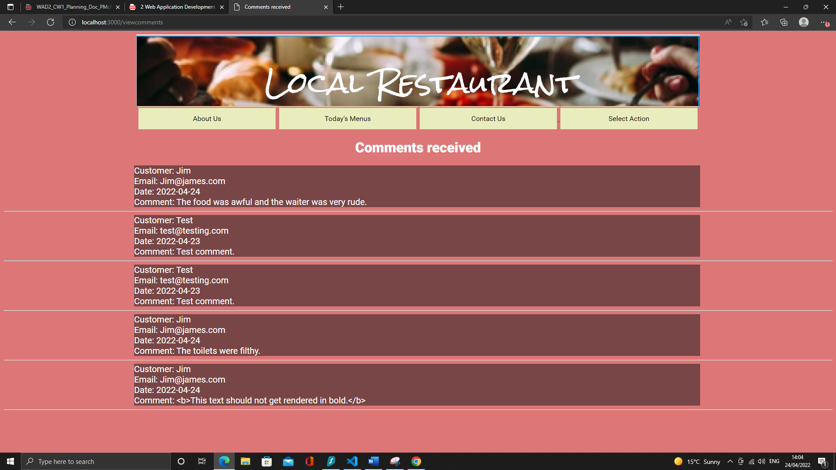

Screenshot 21

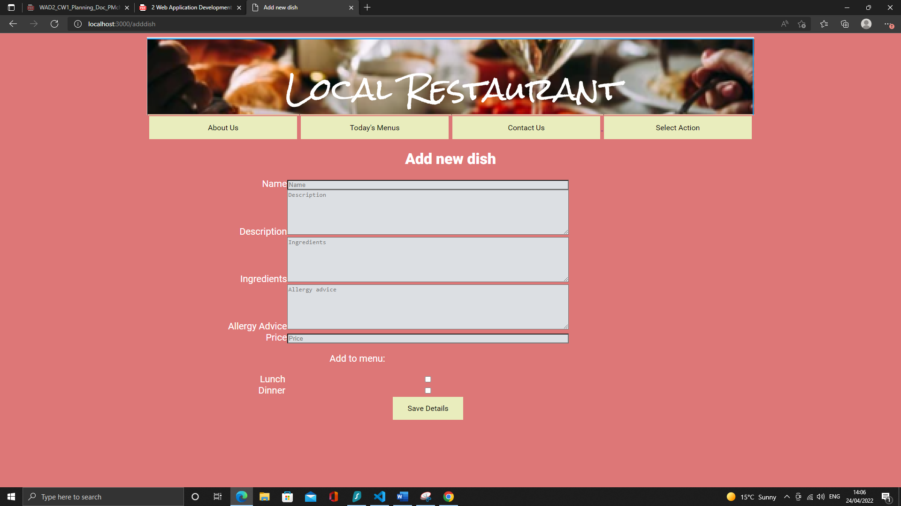

Screenshot 22

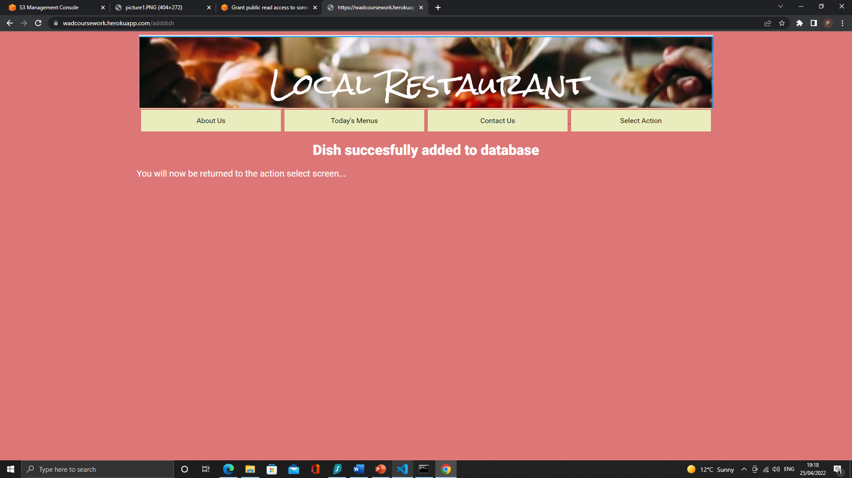

Screenshot 23

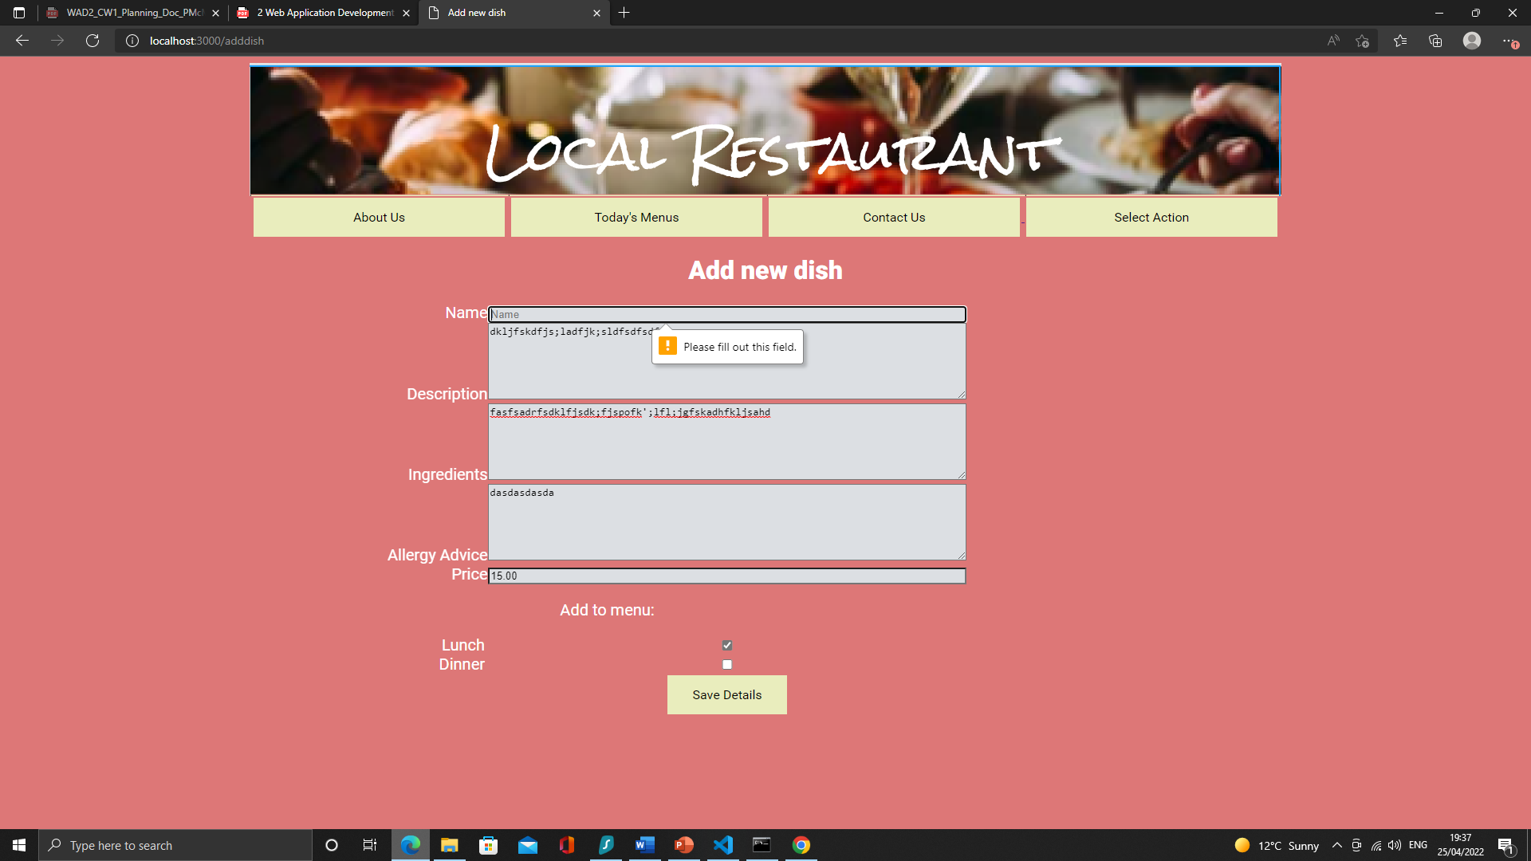

Screenshot 24

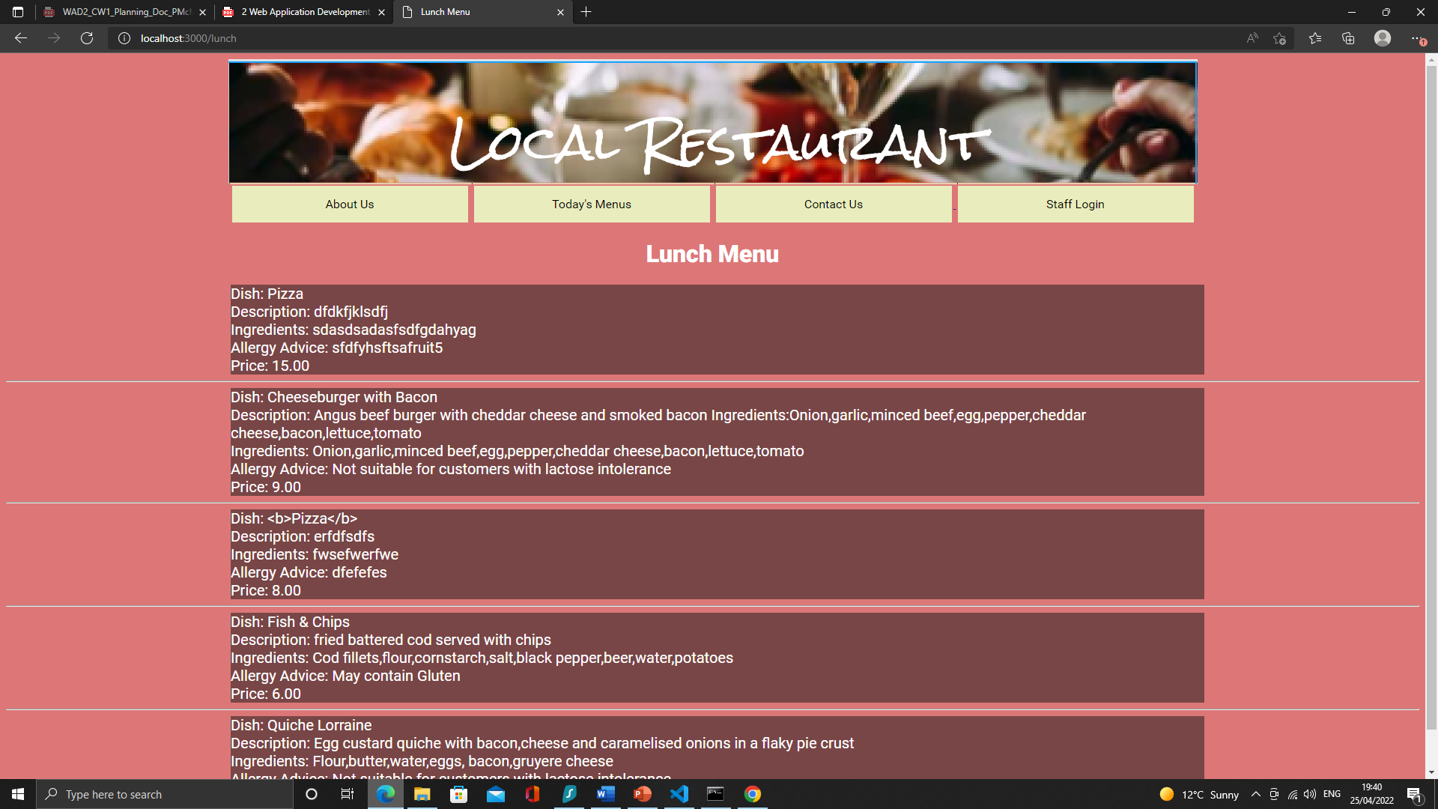

Screenshot 25

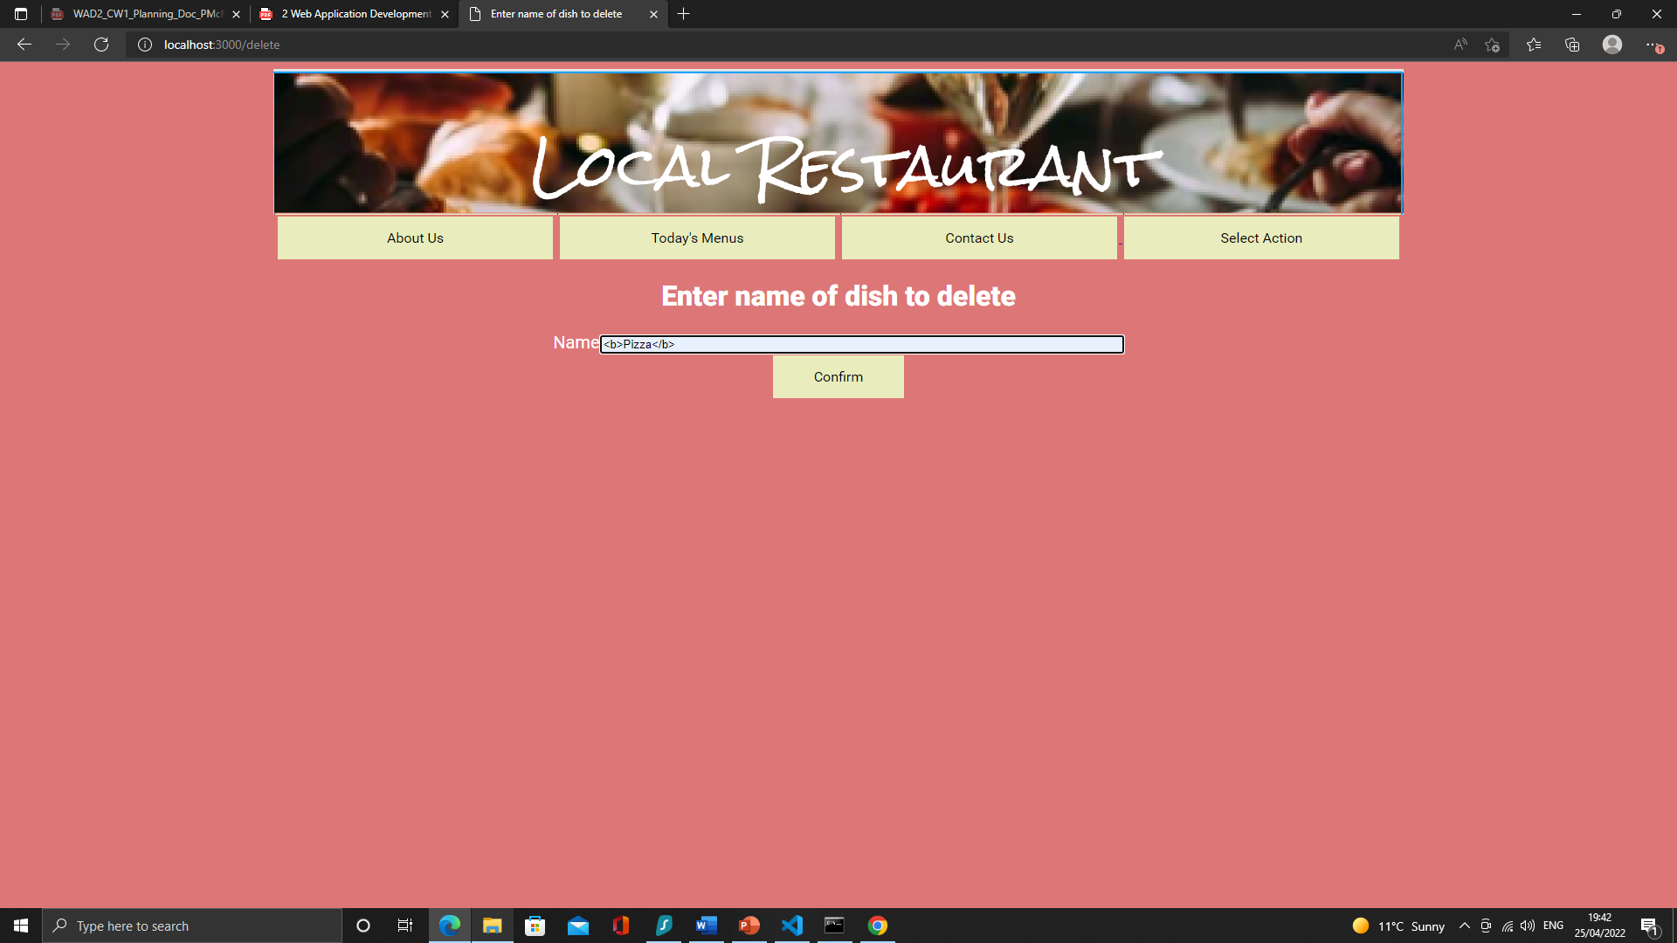

Screenshot 26

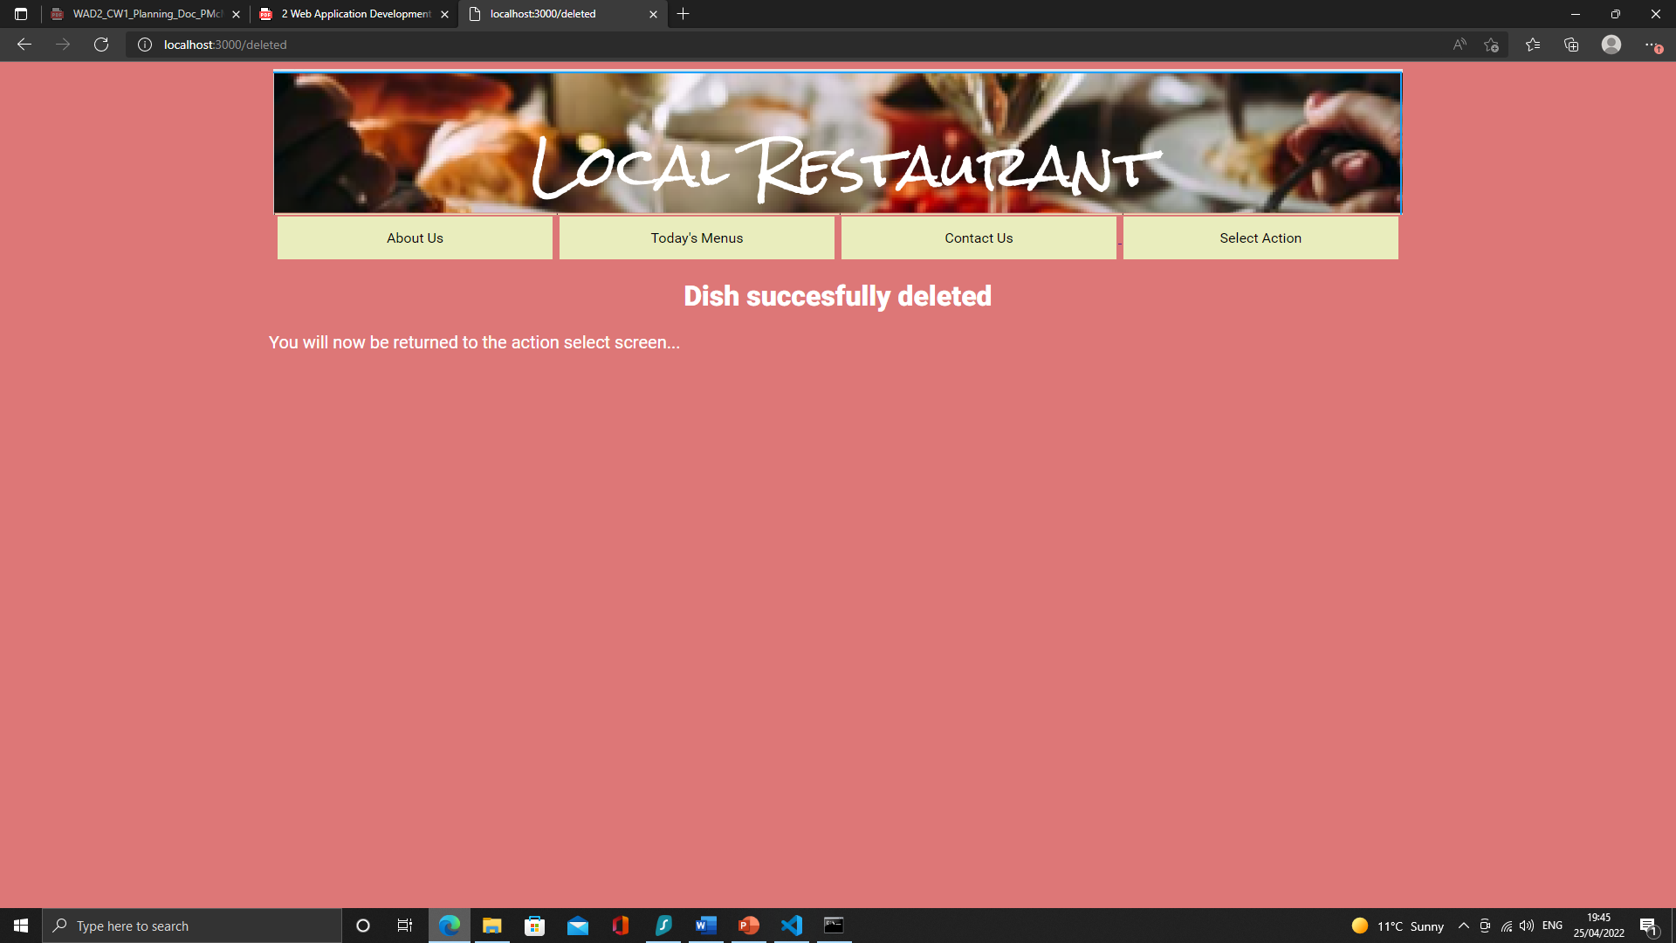

Screenshot 27

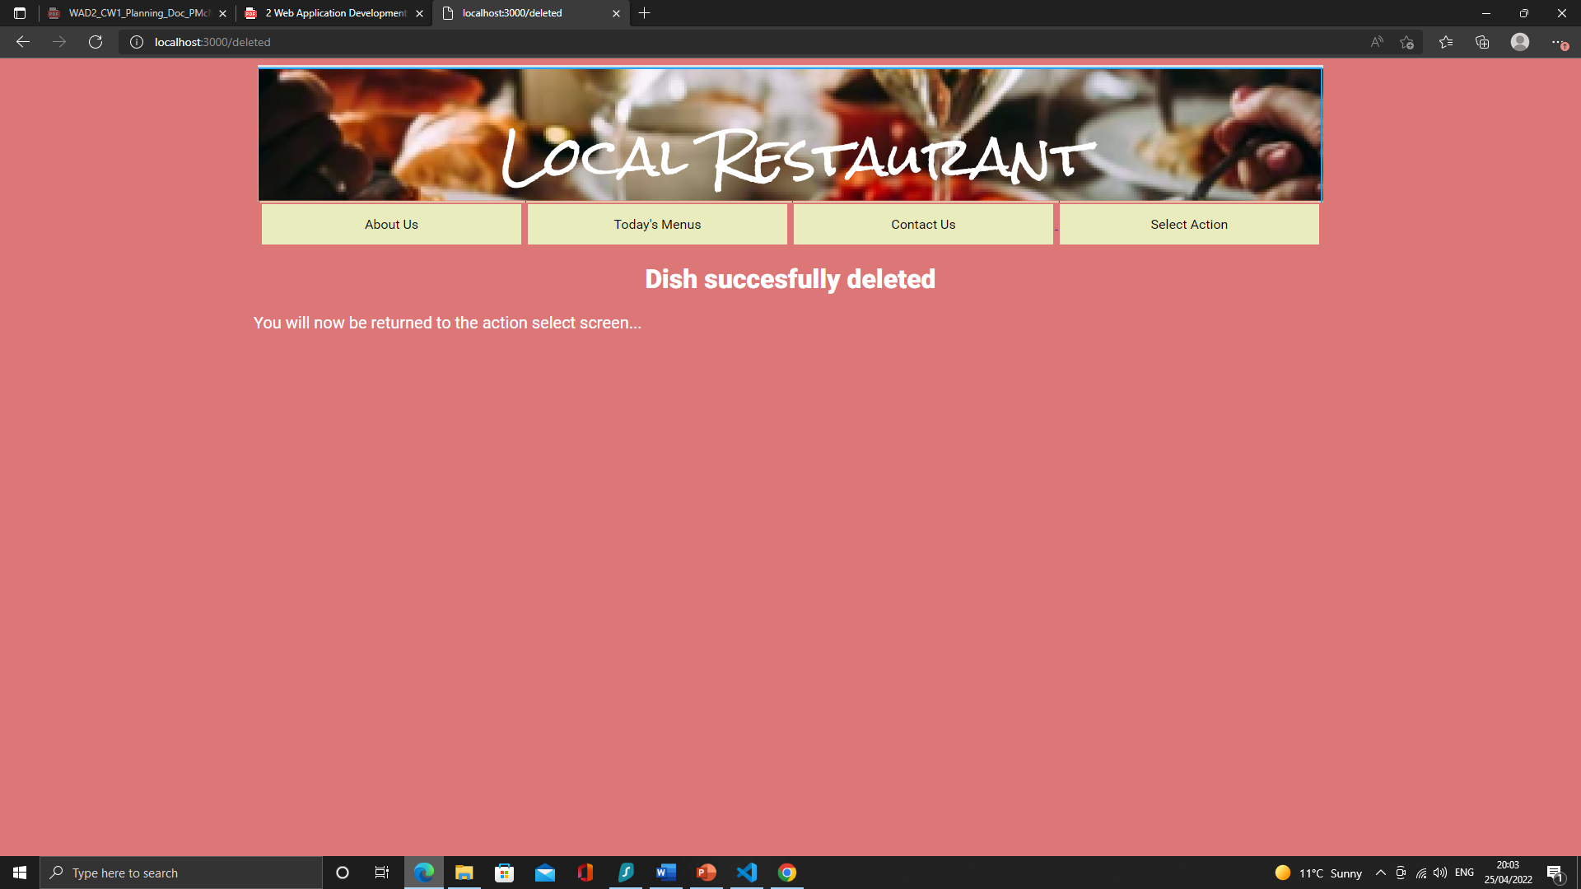

Screenshot 28

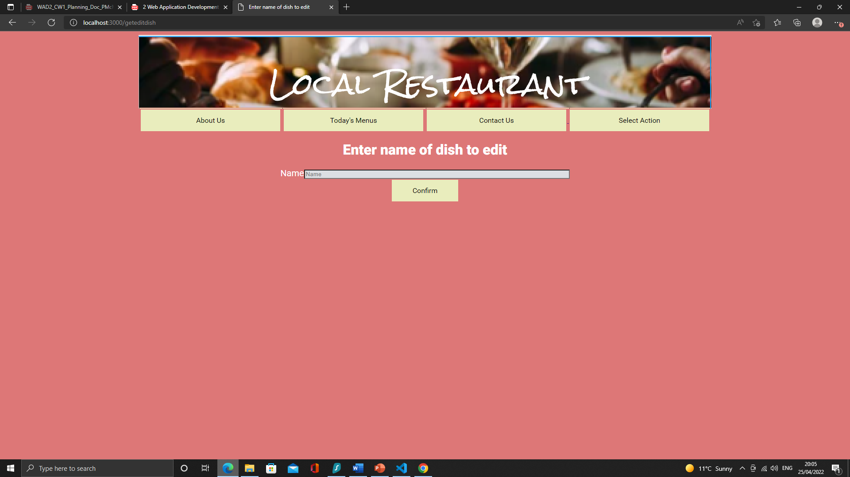

Screenshot 29

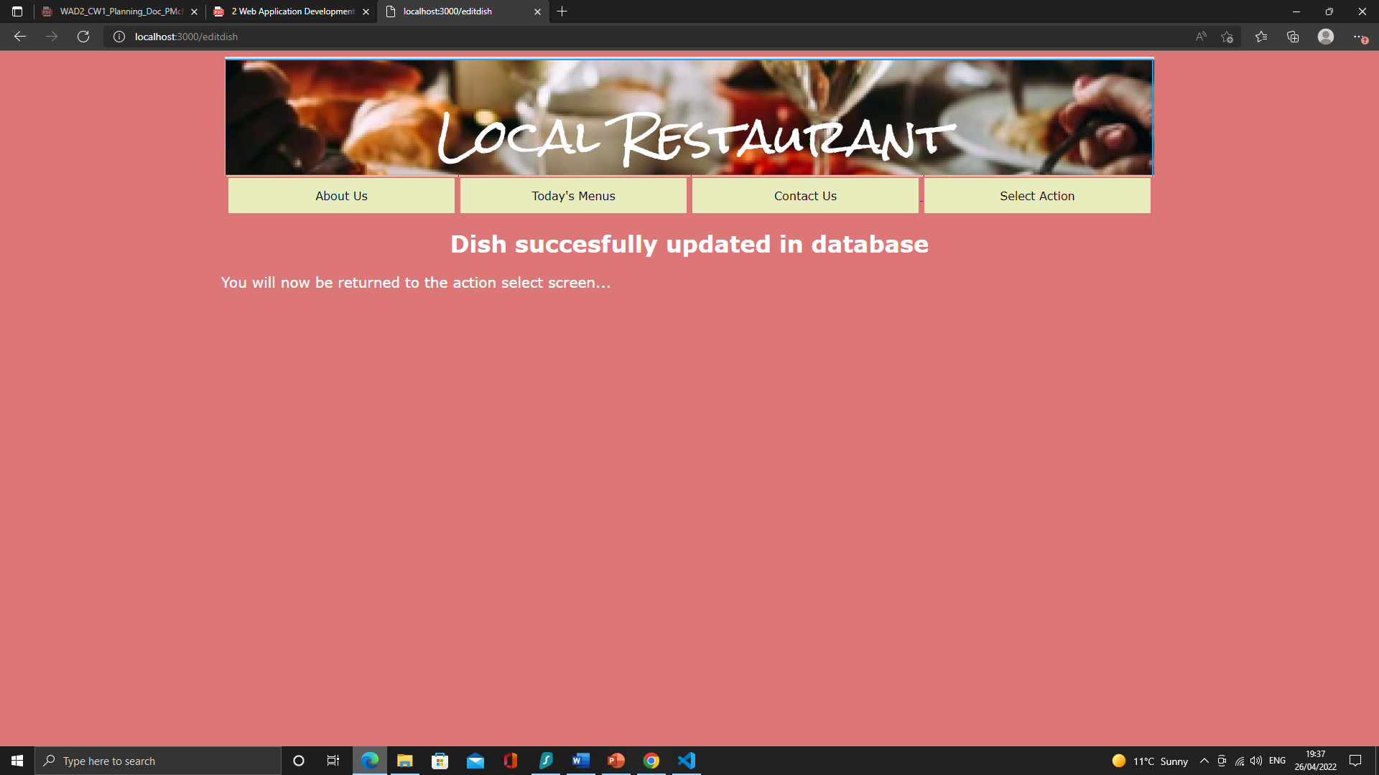

Screenshot 30

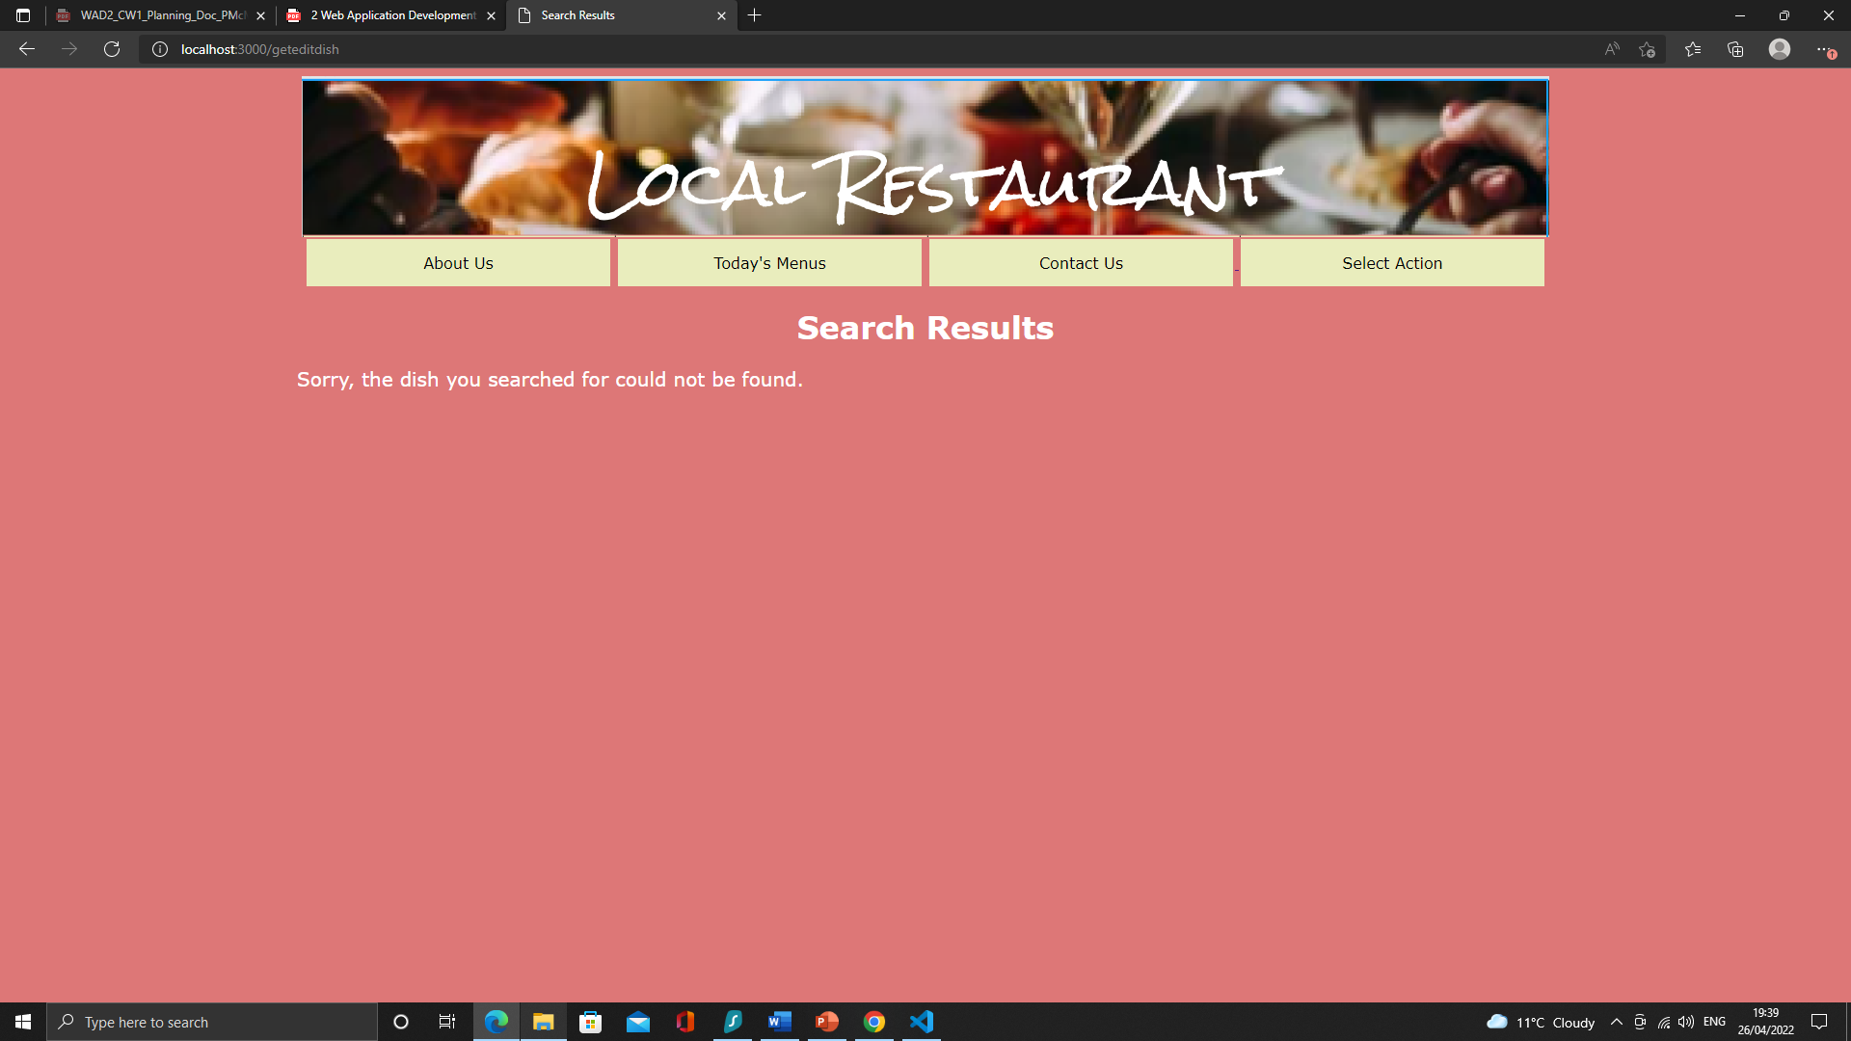

Screenshot 31

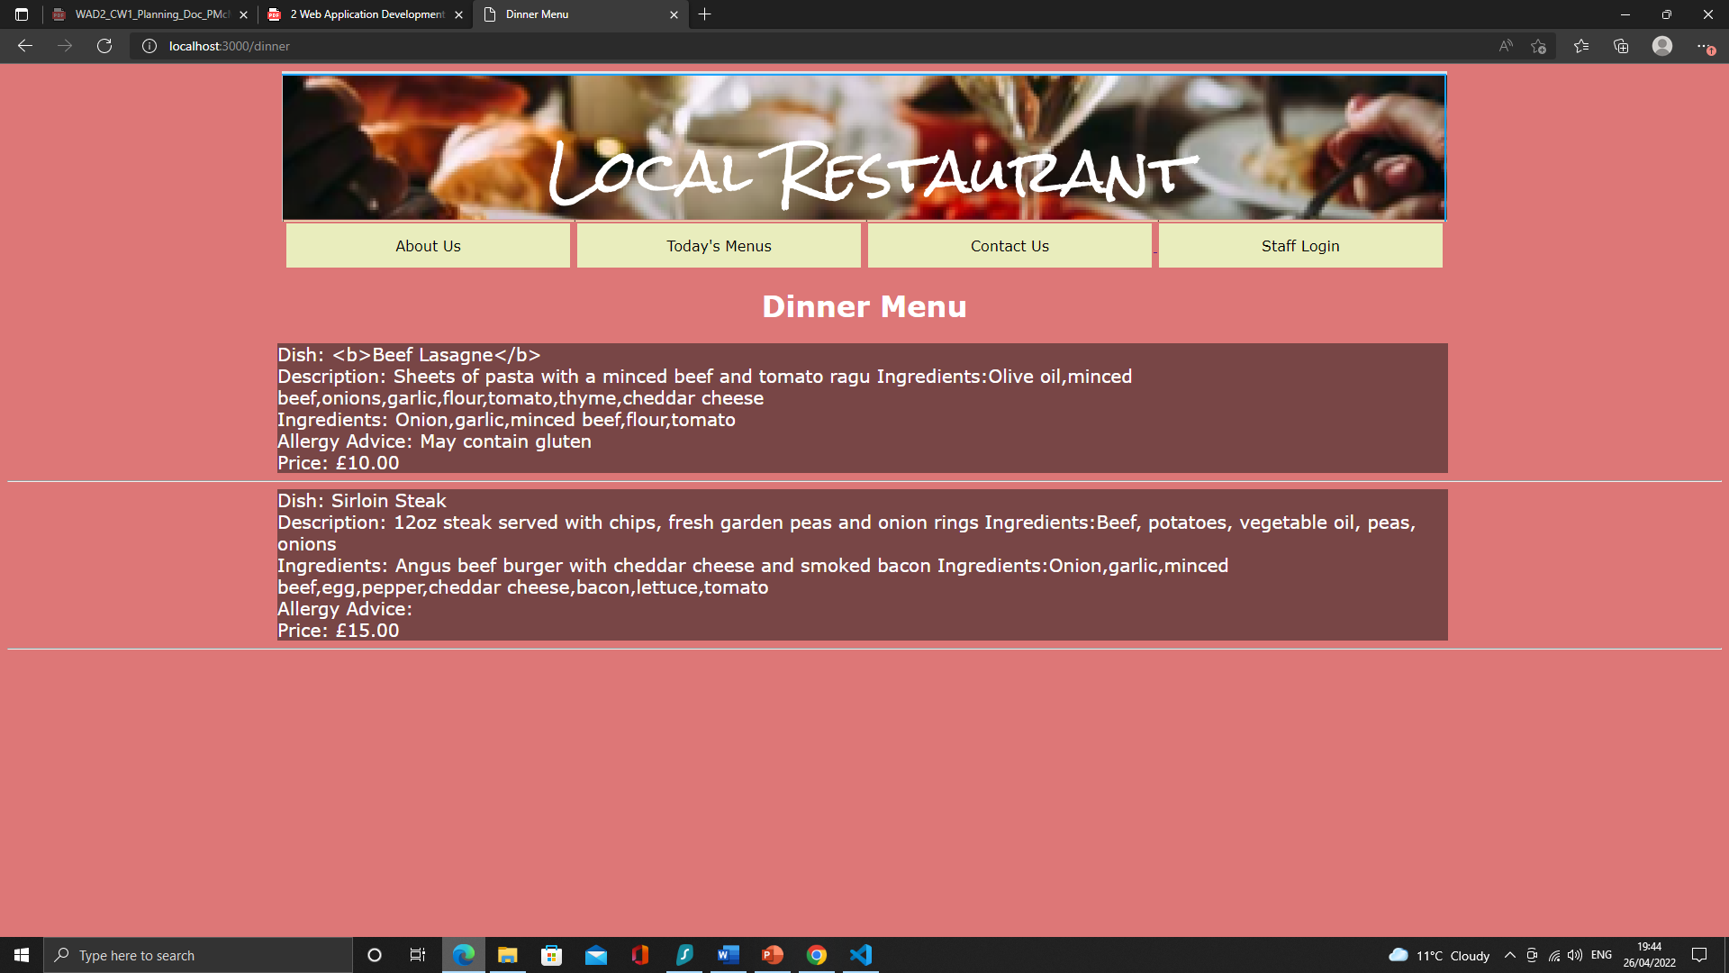

Screenshot 32

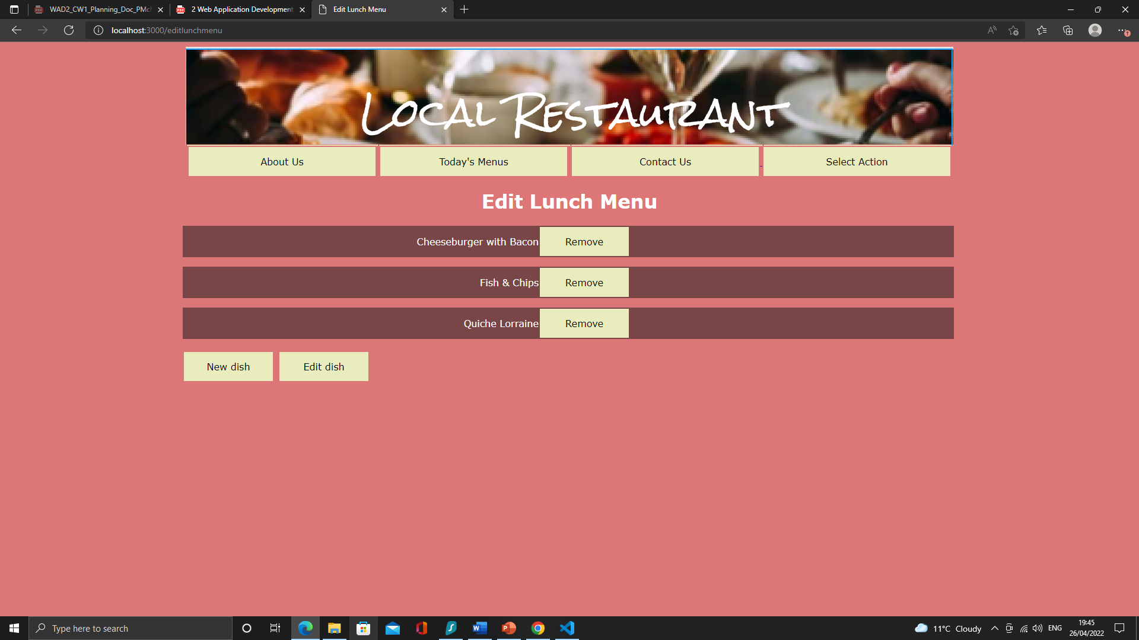

Screenshot 33

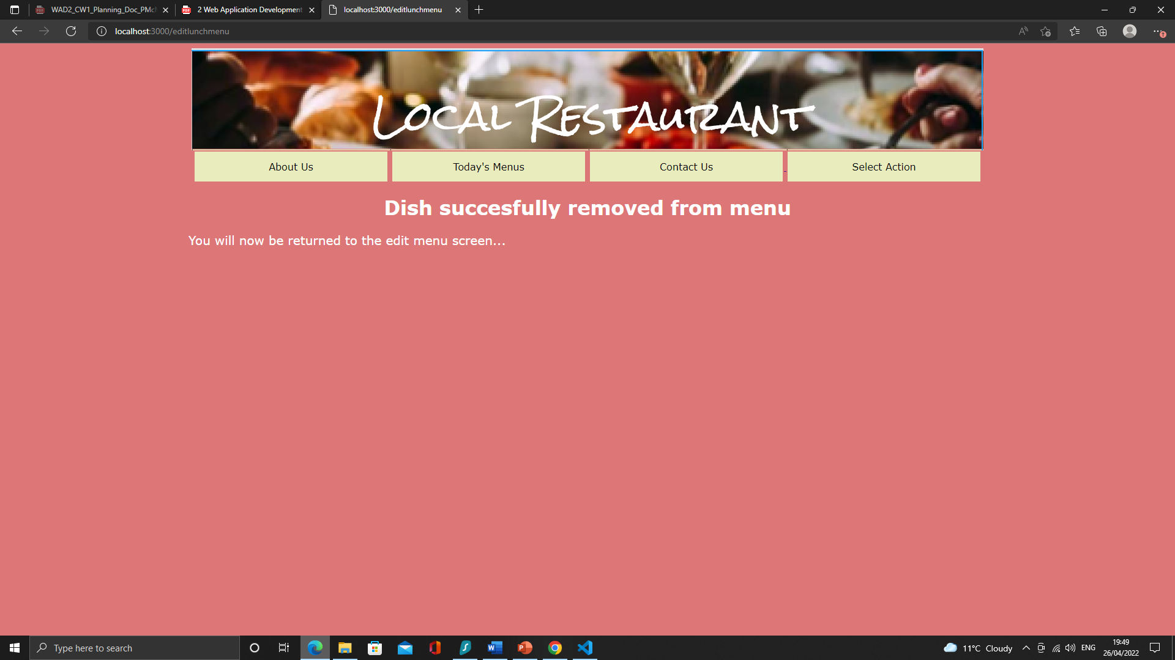

Screenshot 34

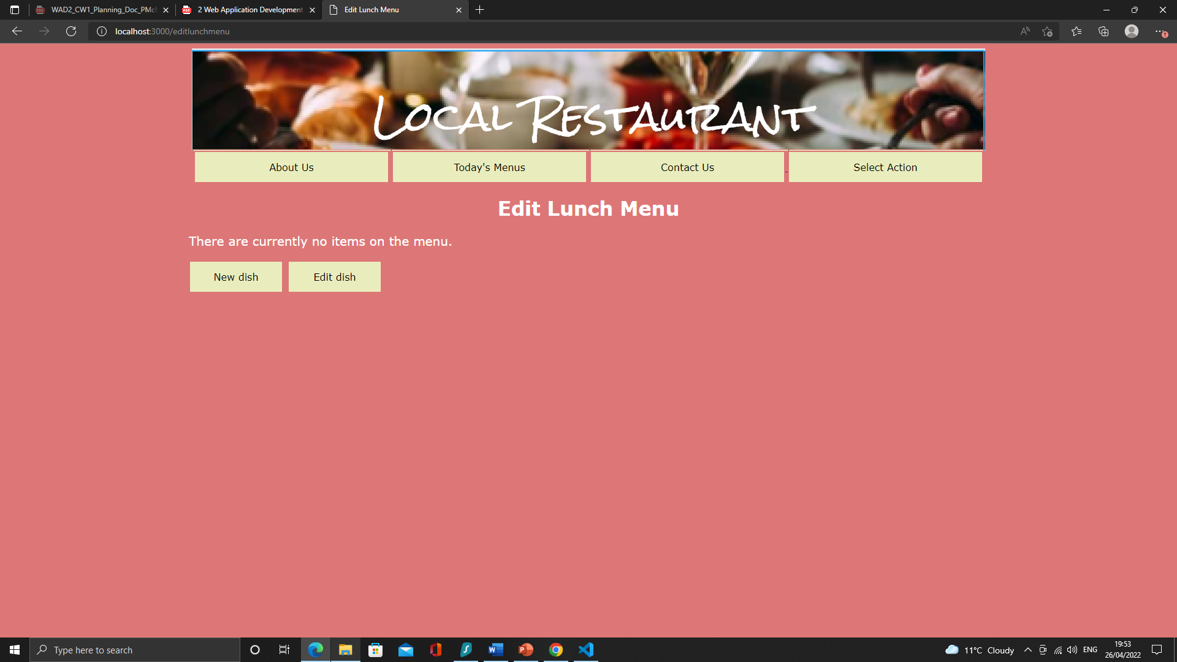

Screenshot 35

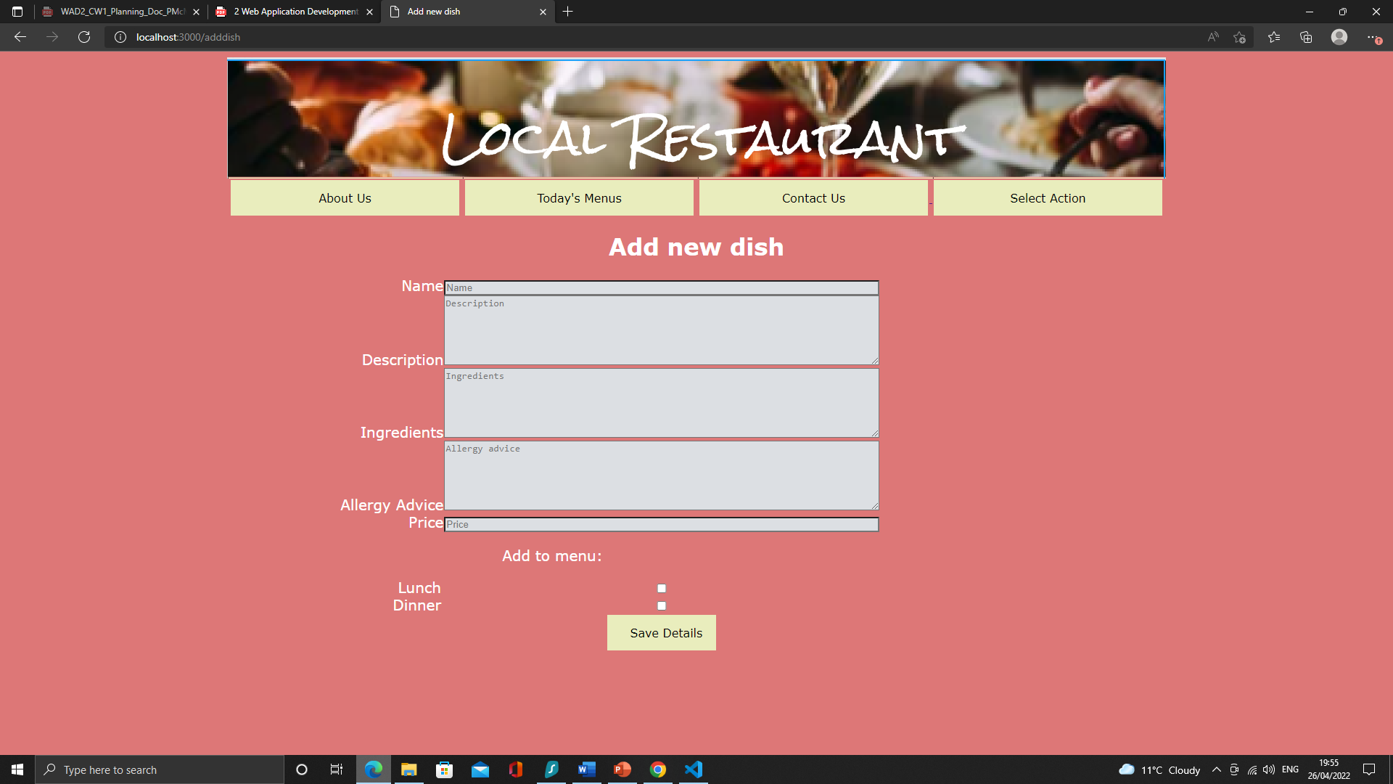

Screenshot 36

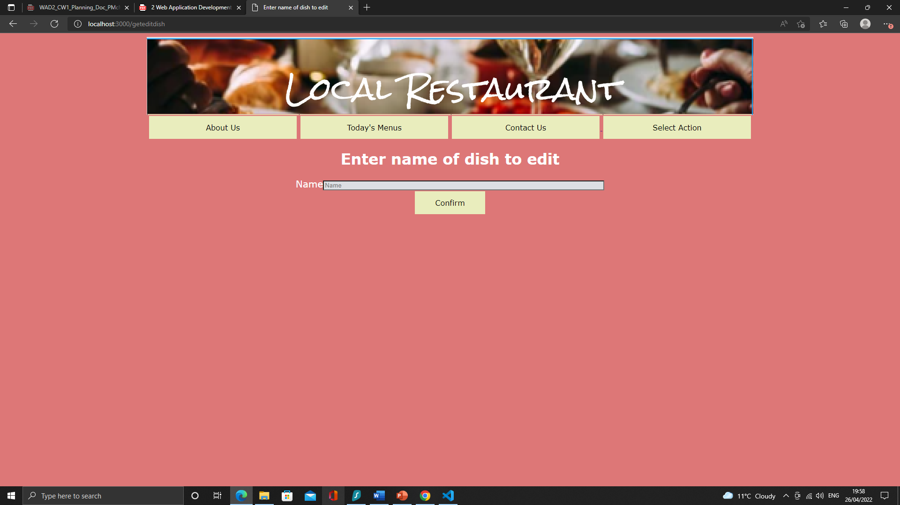Screenshot 37

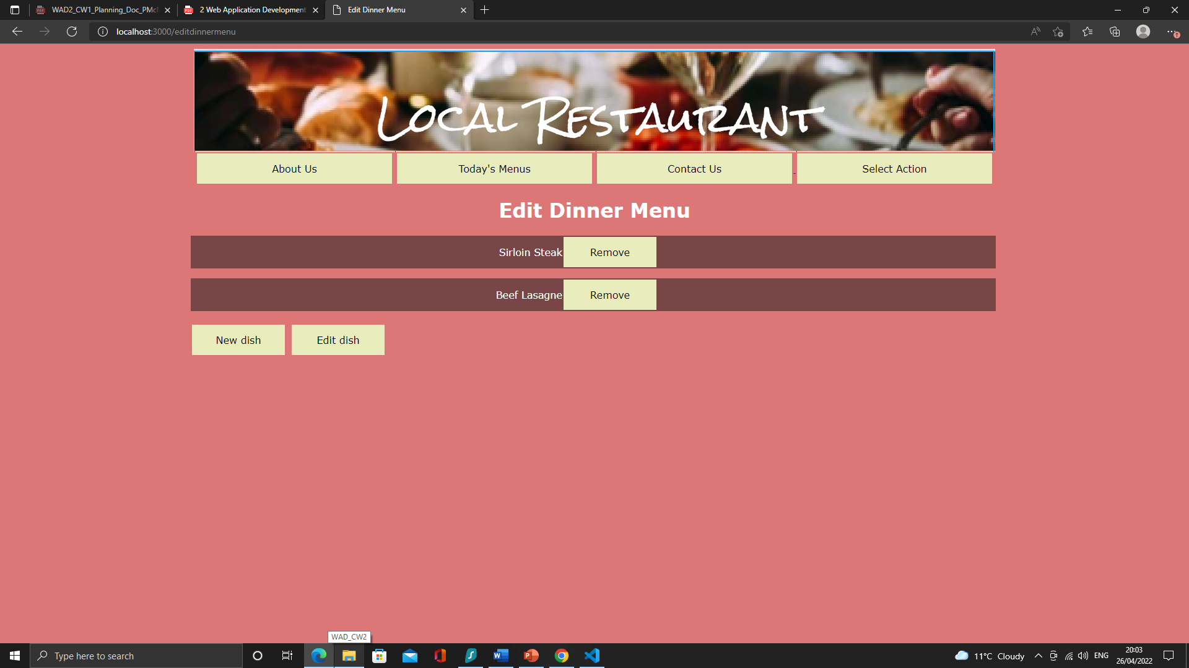

Screenshot 38

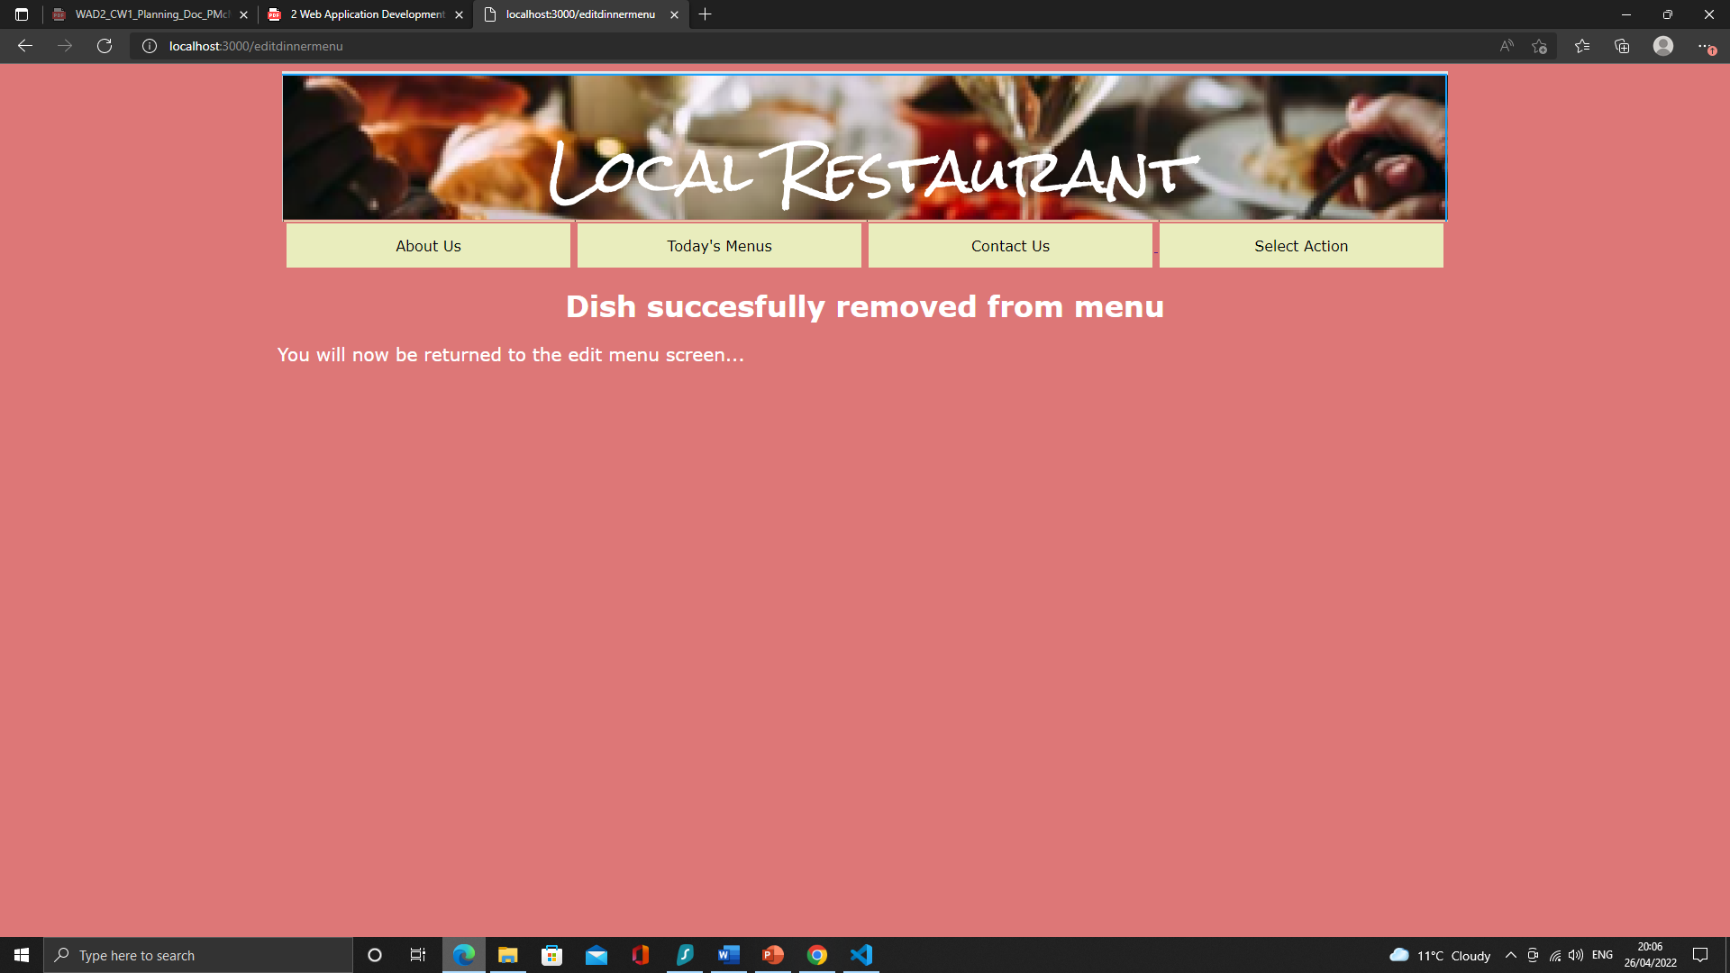

Screenshot 39

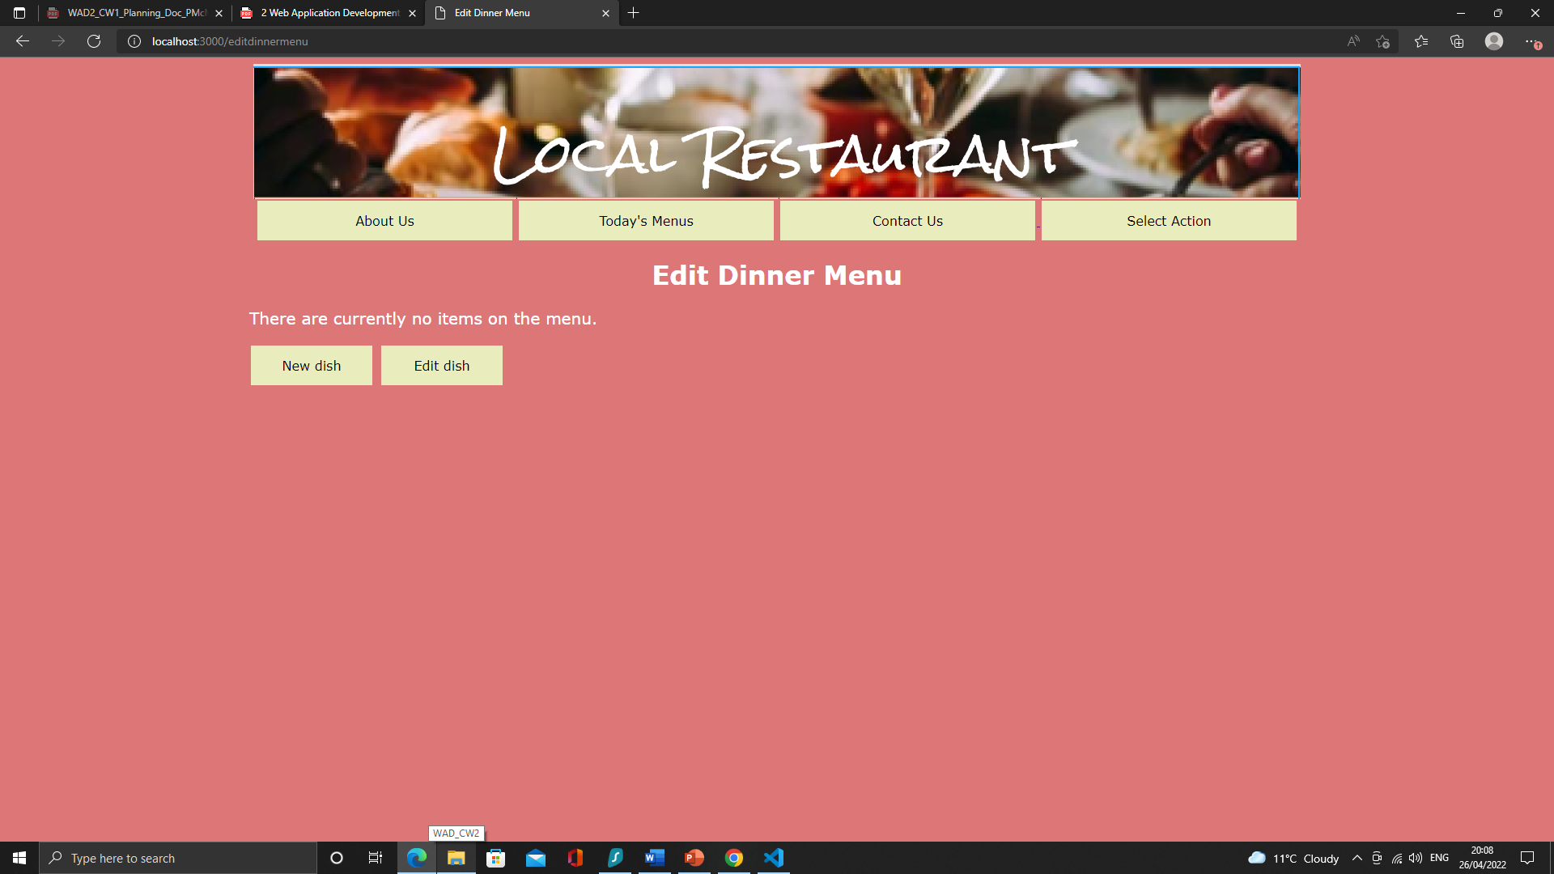

Screenshot 40

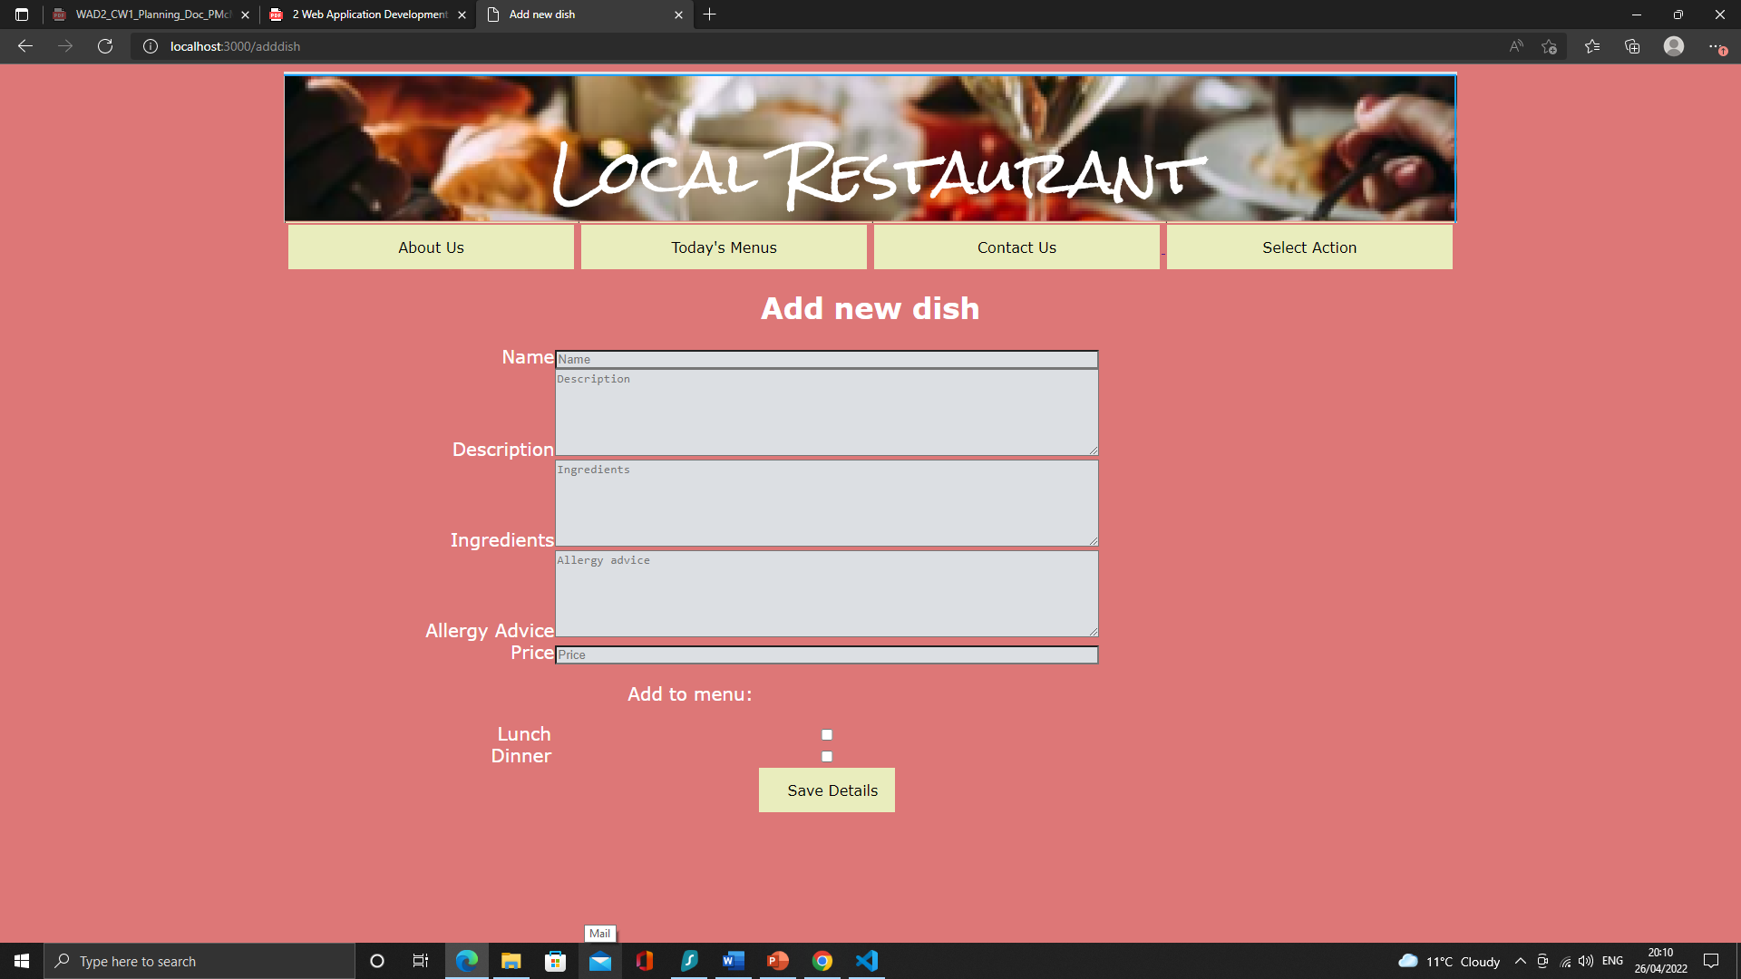

Screenshot 41

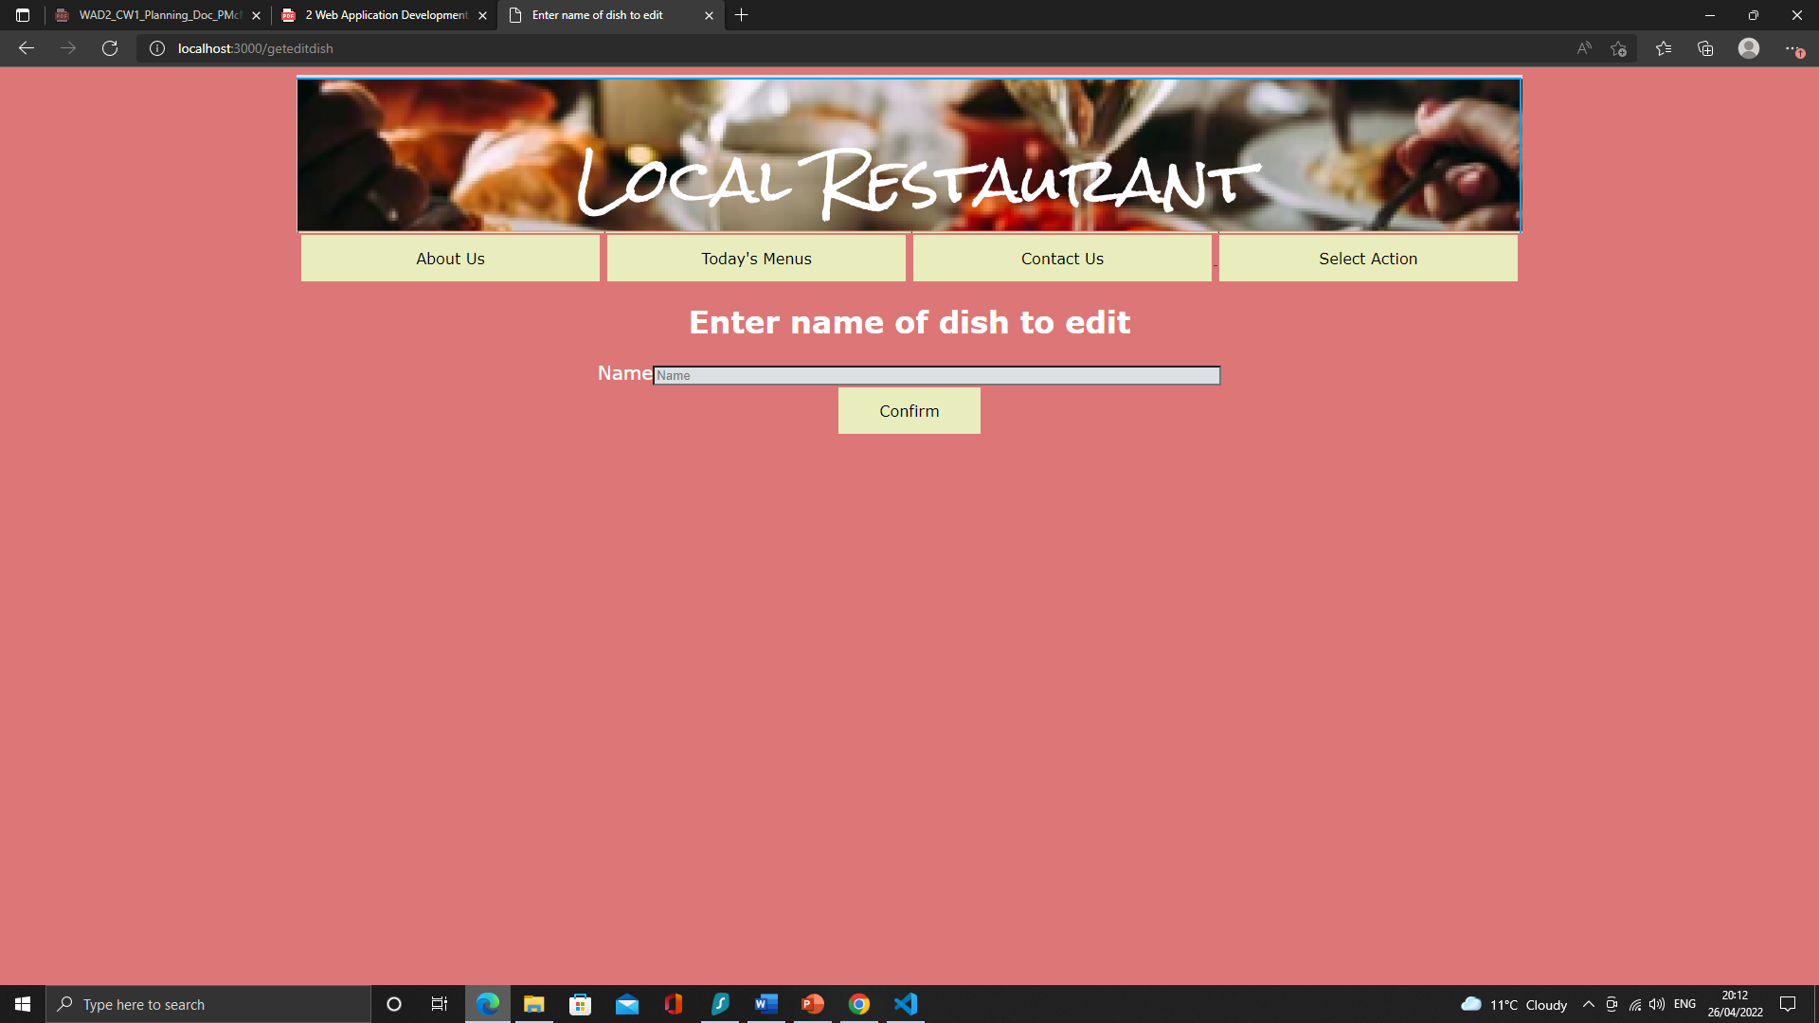

Screenshot 42

## Testing Summary

For the most part the application behaves as expected. Only test 3.8 produced a result different from what was expected. It was anticipated that attempting to delete a non-existent dish would result in some kind of error or crash. In fact, the application behaves as if a dish had been successfully deleted while leaving the database unchanged. With further time to work on the application this could be changed to make it clear the user has entered a non-existent dish and the database will not be changed, it is however good that the application handles this scenario without crashing or throwing error messages.